|  |  |
| --- | --- |
| CRM2016  **Hempel A/S** | What’s new in CRM 2016?  **Angie WONG**  Answers on your most frequent questions about CRM2016 |

Table of Contents

1 How to access CRM 3

1.1 Via Outlook: User can use the shortcut at the bottom 4

1.2 Via Outlook: User can use the menu at the left side 5

1.2 Via web browser: User can access via internet explorer 6

1.4 Via CRM Mobile App for Phone: For IOS, Android or Window Phone 6

2 Navigation menu on CRM Web Client 8

2.1 Area Switch Module 8

2.2 Most Recently Used Items 8

2.2 Quick Create Form 9

2.3 Global Search 9

2.4 Advanced Find 9

2.6 Options 10

2.7 Subareas & Entities 11

2.8 Refresh Grid 11

2.9 Module Recently View Items 11

3.0 Refresh Entity 12

3.1 Associated grid 12

3 Definitions and How to create Lead / Account / Contact / Project 13

3.1 Lead 13

3.1.1 Create Lead 14

3.1.2 To create activities – Task or Appointment 15

3.1.3 To add notes or attachment 16

3.1.4 To toggle between “Summary” and “Details” section 16

3.1.5 To add “Connections” 17

3.1.6 To add competitors related to the lead 18

3.1.7 To reassign the owner of the lead 18

3.1.8 To share the lead to other users or team 20

3.1.9 To disqualify Lead 21

3.1.9 To reactivate Lead 21

3.1.10 To qualify Lead 22

3.2 Account 23

3.2.1 Create Account 25

3.2.2 To assign Primary Contact 26

3.2.3 To create associate Contact 27

3.2.4 To create associate Opportunities 27

3.2.5 To toggle between account form section 28

3.2.6 To create sub account 28

3.2.7 To view associate complaints 29

3.2.8 To add “Connections” 29

3.2.9 To view related connections 29

3.2.10 To create associate Task or mark the task activity as “Completed” 30

3.2.11 To create associate appointment 31

3.2.12 To COPY the CRM account to AX 31

3.2.13 To share the account 32

3.2.14 To print Customer Hierarchy 33

3.2.15 To generate reports 33

3.2.16 To view the out of box hierarchy where it is showing the parent and child account hierarchy 34

3.2.17 To pin the default view that always needed 35

3.2.18 To export data to excel 35

3.2.19 To access the document library folder for accessing generated Sales Invoices, Sales Quotation, Sales Orders or upload any documents related to the account 36

3.2.20 To view the parent child document structure and access the related document folder 38

3.3 Opportunity 39

3.3.1 Create Opportunity 40

3.3.2 To toggle between opportunity form section 42

3.3.3 To move between Stage on opportunity business process and updating field under each Stage 42

3.3.4 To add the Contact involved for the project 43

3.3.5 To view the Pipeline Phase History Time Stamp 44

3.3.6 To add competitors 44

3.3.7 To add user for the Sales team that involved on the project 45

3.3.8 To add connection 45

3.3.9 To access the document library folder for accessing IQS Quotation or Specification related to the Opportunity 47

3.4.0 To assign or Share Opportunity to another user 49

3.4.1 To COPY opportunity 49

3.4.2 To Close the Opportunity as Won or as Lost 50

3.4 Contact 51

4 How to create a view 52

5 Merging and Deactivate of duplicates 55

# 1 How to access CRM

There are 3 ways to start working with CRM

## Via Outlook: User can use the shortcut at the bottom

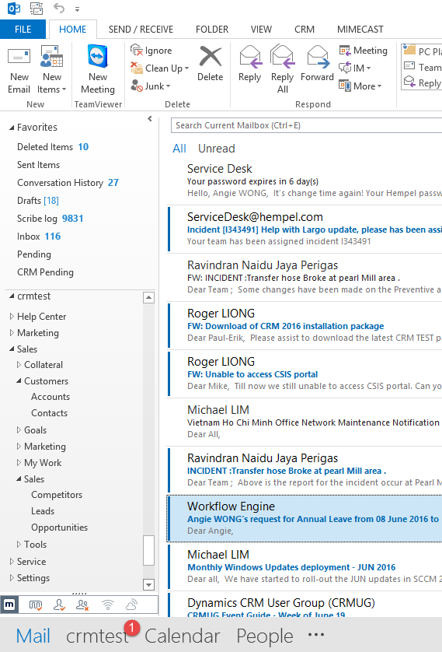 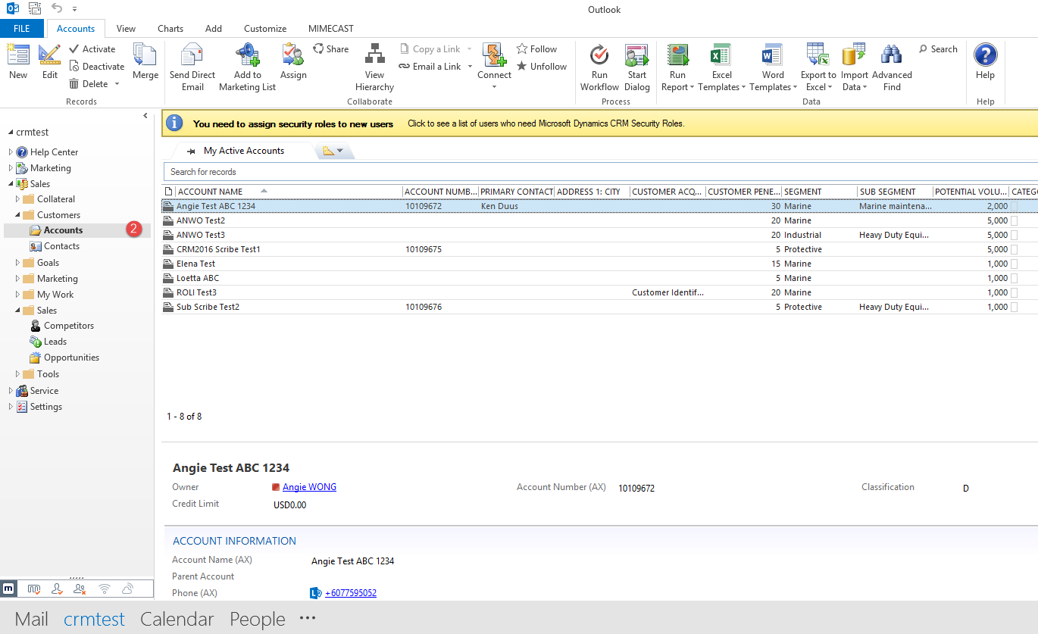

## 1.2 Via Outlook: User can use the menu at the left side

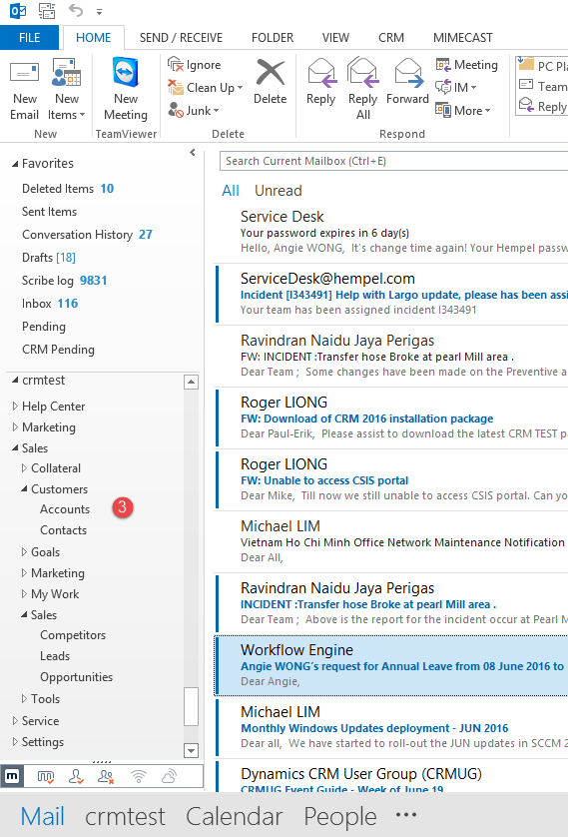

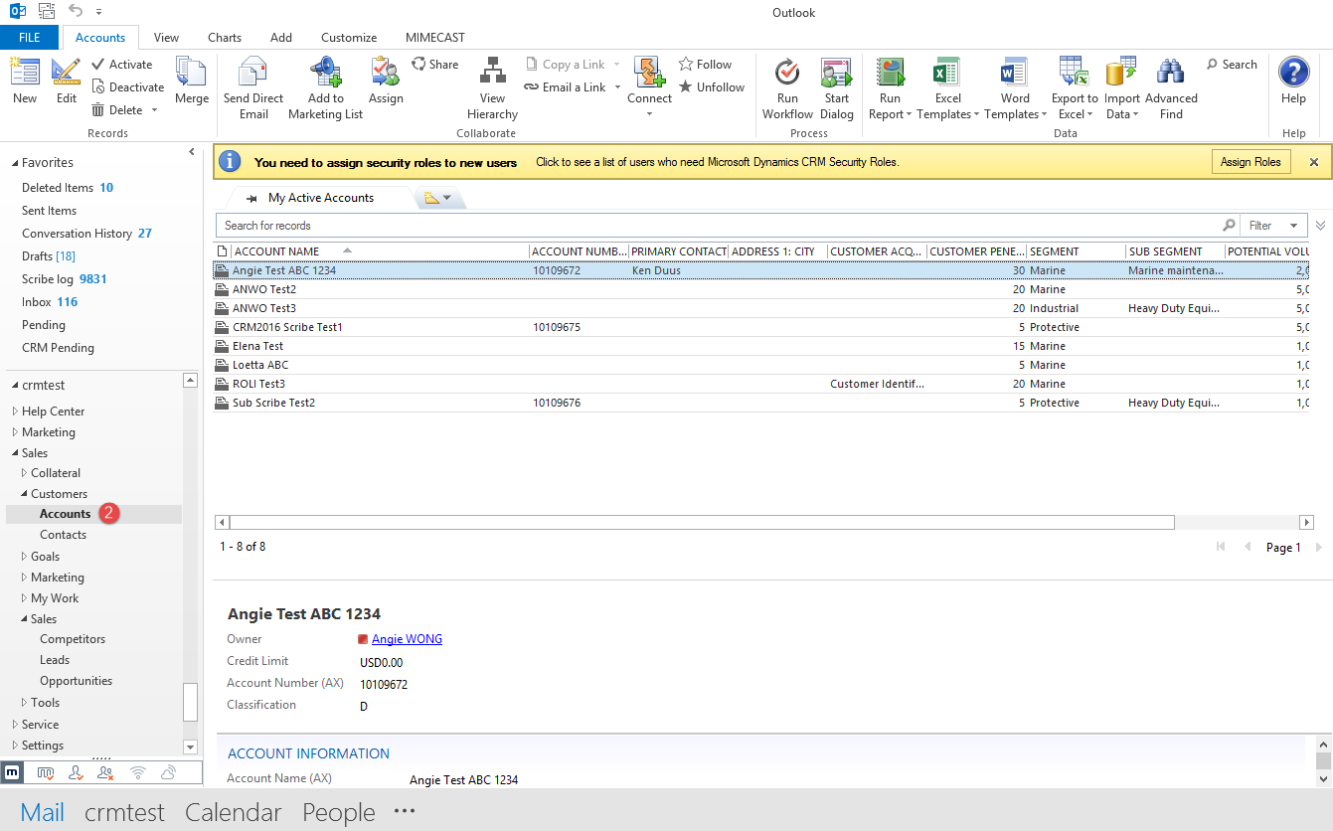

## Via web browser: User can access via internet explorer

To access CRM2016 Tester server, just type <https://crm2016test/crmtest/main.aspx> in the web address field and click “enter”

Notes:

1. CRM2016 Live server - <https://crm2016live/crmlive/main.aspx>
2. CRM2016 Test server - <https://crm2016test/crmtest/main.aspx>

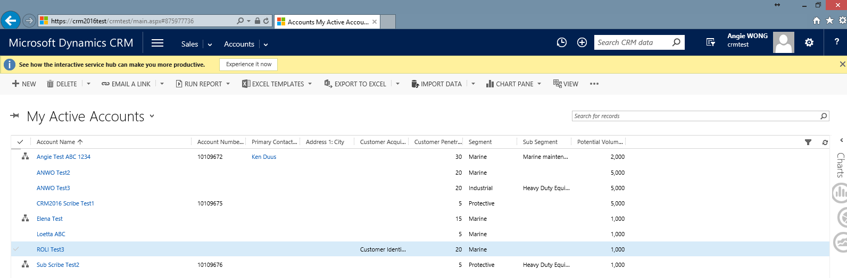

## 1.4 Via CRM Mobile App for Phone: For IOS, Android or Window Phone

1. After enrolled our mobile with Hempel, the policy will automatically install the Dynamics CRM for Phone to our mobile phone
2. First time accessing, the system will request us to create 4 digits pin where it is a pin that our company used to protects data in this app
3. Every time we must enter our pin before go to access the CRM data via the CRM Mobile App.

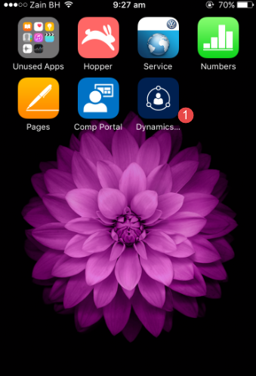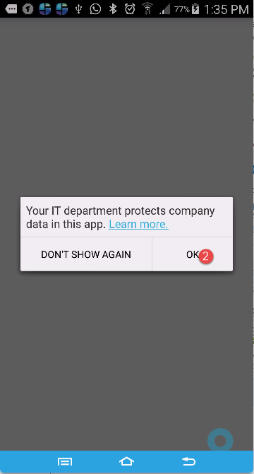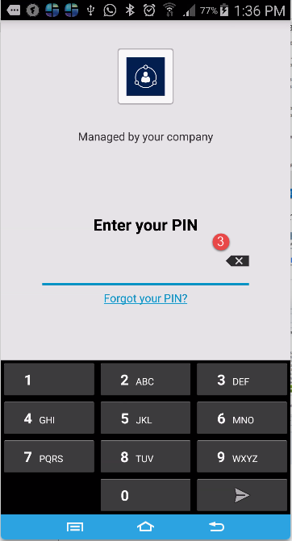

1. Configure the server address:-
2. CRM2016 Live server – <https://crmlive.hempel.com>
3. CRM2016 Test server - <https://crmtest.hempel.com>
4. Sign in with window username and password.

Notes: Only need to enter the username and password every 7 days

1. Waiting for the system to load the crm data

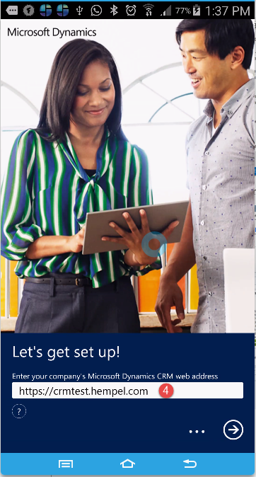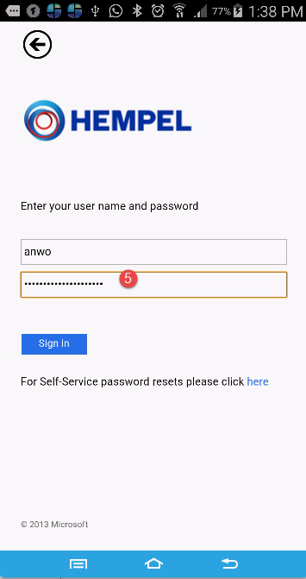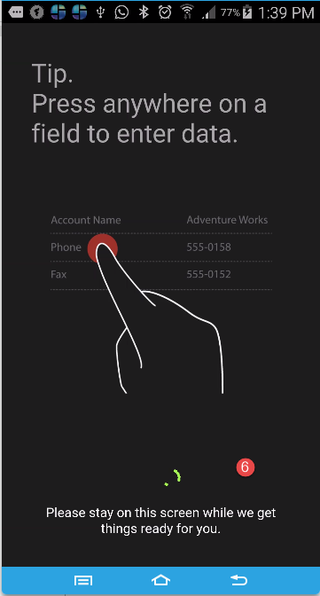

1. Home screen
2. Main menu navigation
3. My active Accounts view

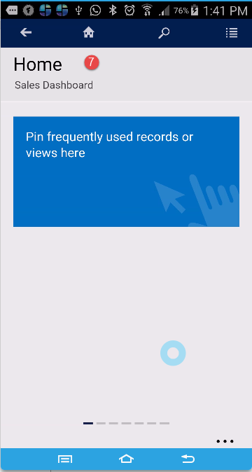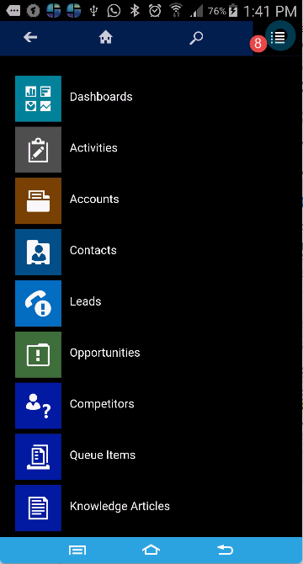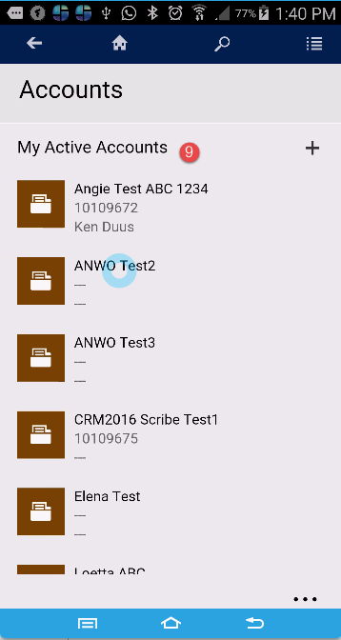

# Navigation menu on CRM Web Client

The Microsoft Dynamics CRM navigation menu is changing. Here’s a diagram of the navigation bar:

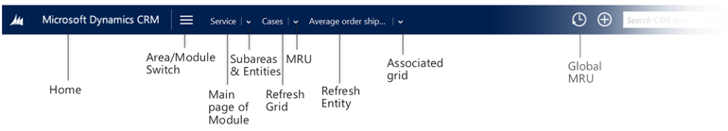

## Area Switch Module

http://www.preact.co.uk/media/images/media/switch-act.jpg

This icon used to switch between the main navigation sections, e.g Sales, service, marketing, settings. The major benefit is that users can now switch between these sections in a single click without having to wait for the page to reload.

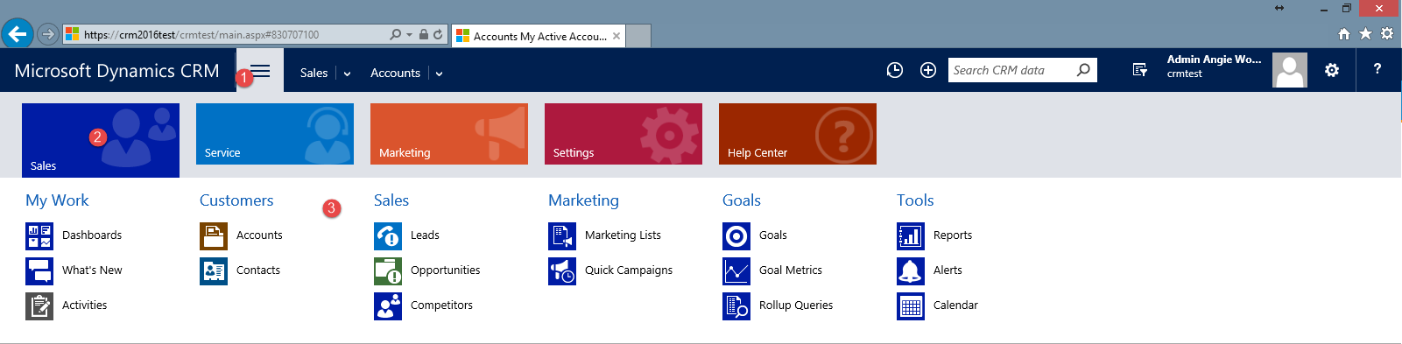

## 2.2 Most Recently Used Items

http://www.preact.co.uk/media/images/media/globalmru.jpg

A new shortcut display to access up to 30 recently viewed records & pin your frequently used records & views.

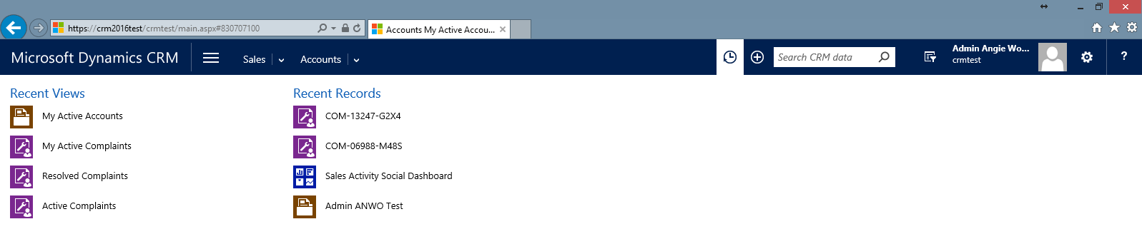

## Quick Create Form



Quick create button, which, as the name suggests, brings up a simple and easy-to-use menu to create common CRM tasks in a flash.

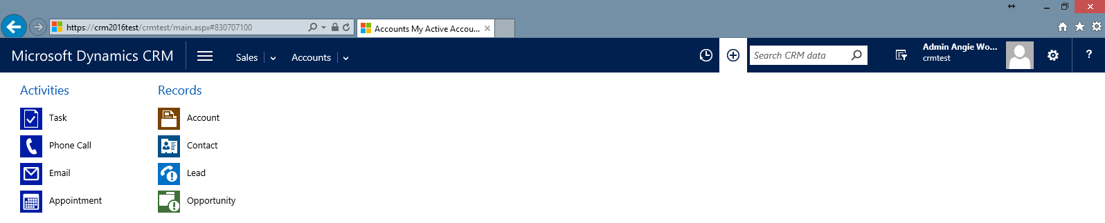

## Global Search



You can enter your search string then CRM will list out all the configured entity records if found. Once you have result you can also filter it based on specific entity using Filter with dropdown next to search text box.

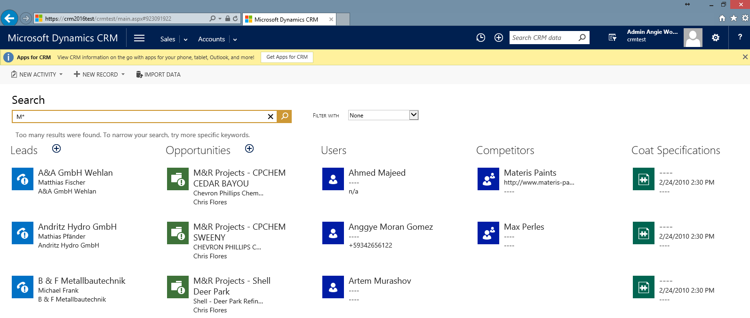

## Advanced Find



Find the records you want in Microsoft Dynamics CRM by using the Advanced Find command. You can also use Advanced Find to prepare data for export to Microsoft Office Excel so that you analyse, summarize, or aggregate data, or create PivotTables to view your data from different perspectives.

## 2.6 Options

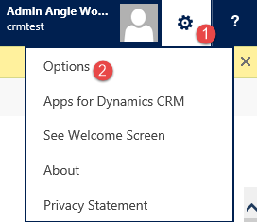

Personalize your Microsoft Dynamics CRM workspace to suit your requirements or preferences. For example, you can choose the page that you want to see as soon as you sign in to CRM. You can also personalize many other options such as language, currency, and time zone.

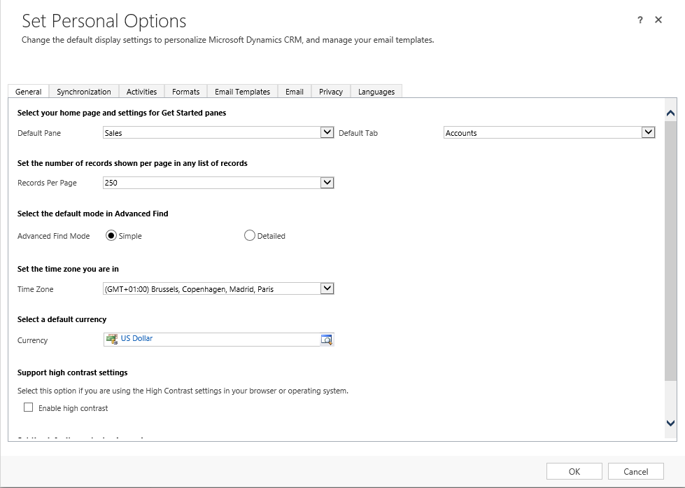

## 2.7 Subareas & Entities

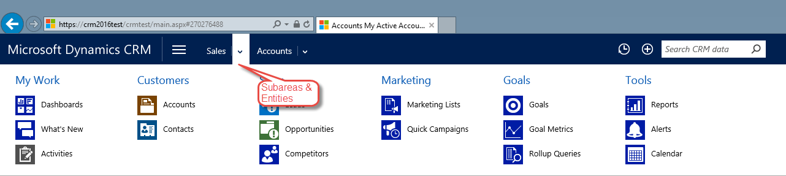

You can access list of modules available under Sales section

## 2.8 Refresh Grid

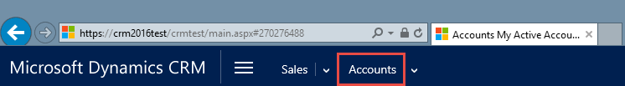

You can click on the section in order to refresh the “My Active Accounts” view

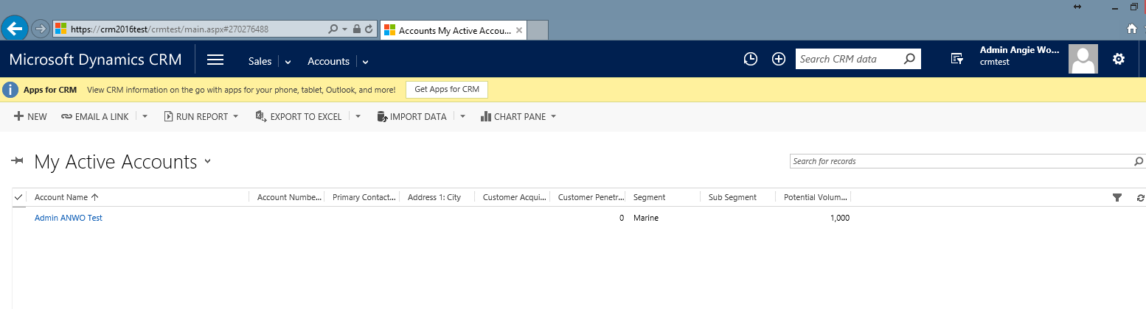

## 2.9 Module Recently View Items

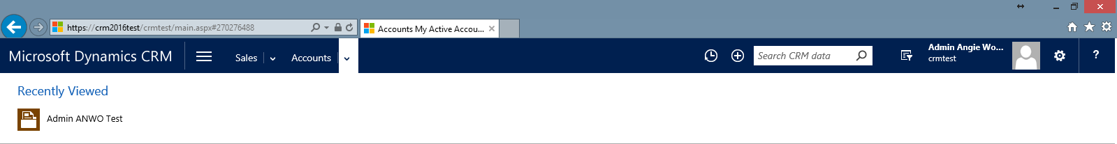

You can easily access to recent view items for Accounts etc

## 3.0 Refresh Entity

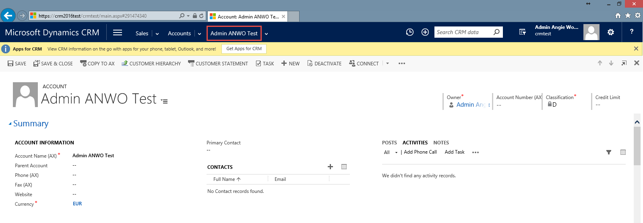

You can click on the account name to refresh the account with the latest update.

## 3.1 Associated grid

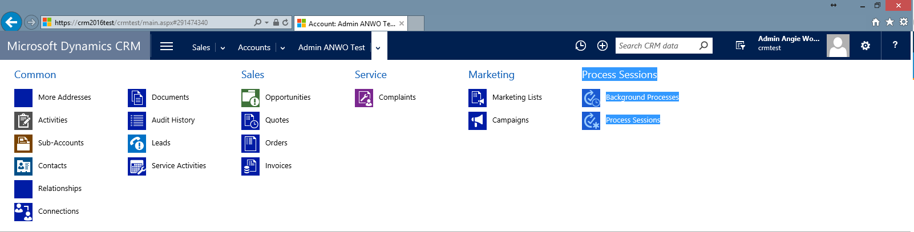

The common menu for each of the records. For example, Activities associated with account Admin ANWO Test or Opportunities associated with account Admin ANWO Test

# 3 Definitions and How to create Lead / Account / Contact / Project

Data in the CRM system is mainly organized by the following 4 “entities”: Leads, Accounts, Contact and Opportunity. Before creating a new record in CRM (contacts, projects, accounts) please check if it is not already created by your colleagues.

## 3.1 Lead

**A Lead is a potential unqualified target for sales meaning a potential Customer (Account) or** **Opportunity.** So a New Lead is a customer or project where we have still not confirmed if there is any short or long term interest. An example could be a list of customers that we buy from e.g. research companies (procured marketing lists) or projects a sales guy has seen on the road or read about in the press. Other Lead sources could be Contacts from trade show, respondents to surveys, etc.

|  |  |
| --- | --- |
| **General** |  |
| Topic* | What is the leads about? |
| First Name | Given Name |
| Last Name * | Family Name, Mandatory |
| Salutation | Mr. / Mrs. / Cpt. / Dr. etc |
| Rating | Classification of the leads |
| Currency | Currency that customer will transact in |
| Trade Code | Detailed Sub Segment |
| **Contact Information** |  |
| Business Phone | No spaces between city codes and phone numbers |
| Fax | No spaces between city codes and phone numbers |
| Home Phone | No spaces between city codes and phone numbers |
| Other Phone | No spaces between city codes and phone numbers |
| Mobile Phone | No spaces between city codes and phone numbers |
| Description | Additional background or remarks about Leads (Use notes for attachments) |
| Country* | Location of company business registration |
| **Company Information** |  |
| Annual Revenue | How much would you estimate our Annual Revenue to be if we can convert this Lead to an Account? |
| No of Employees | How many people work for the Lead? |
| **Leads Information** |  |
| Lead Source | How did we get to know this Lead? |
| **Preference** |  |
| Owner* | Hempel employee that created the account OR is assigned/responsible to serve the Lead |
| Source Campaign | If we got this Lead from one of our Marketing Campaigns you can add the Campaign here. |

### 3.1.1 Create Lead

#### 3.1.1.1 To create a lead using complete form, click on “New” in the “Leads” section

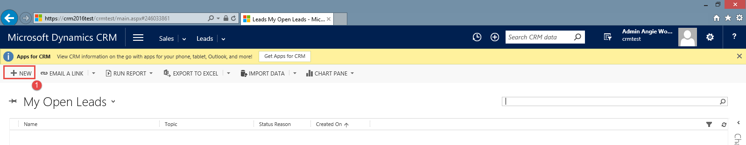

Please note, that all fields, which are marked with a red star, are mandatory to be filled out.

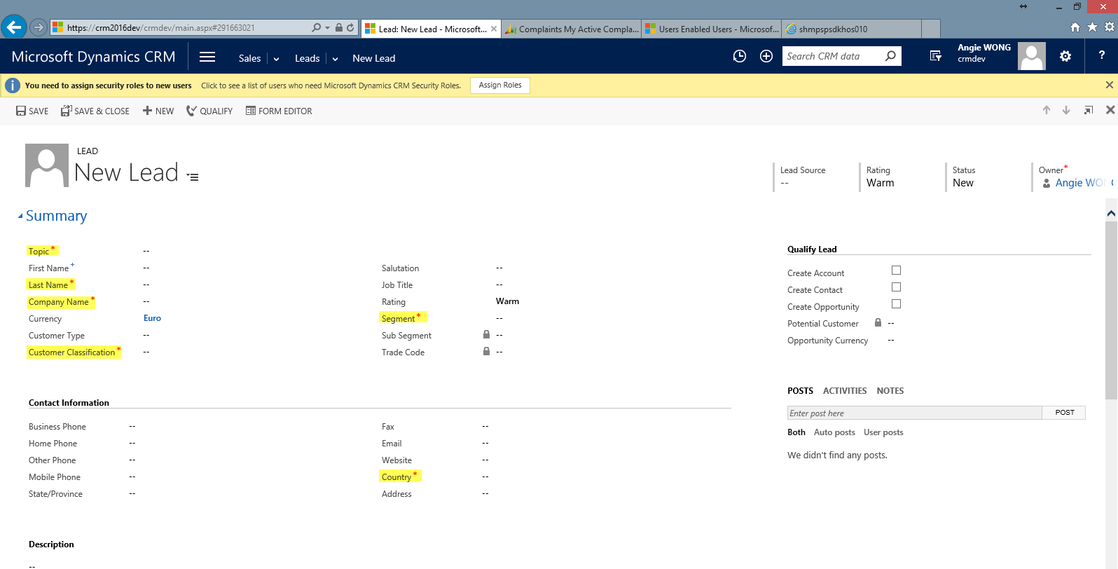

#### 3.1.1.2 To create lead using simple form, click on Quick Create Items -> “Lead” section

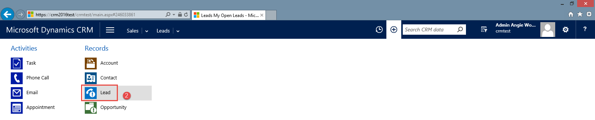

Please note, that all fields, which are marked with a red star, are mandatory to be filled out.

### 3.1.2 To create activities – Task or Appointment

1. Users should not add Task from the Activities section as the Task form didn't include the Category selection
2. Users can add Appointment from the Activities section
3. Users can click to see the associate activities and choose to add the new task

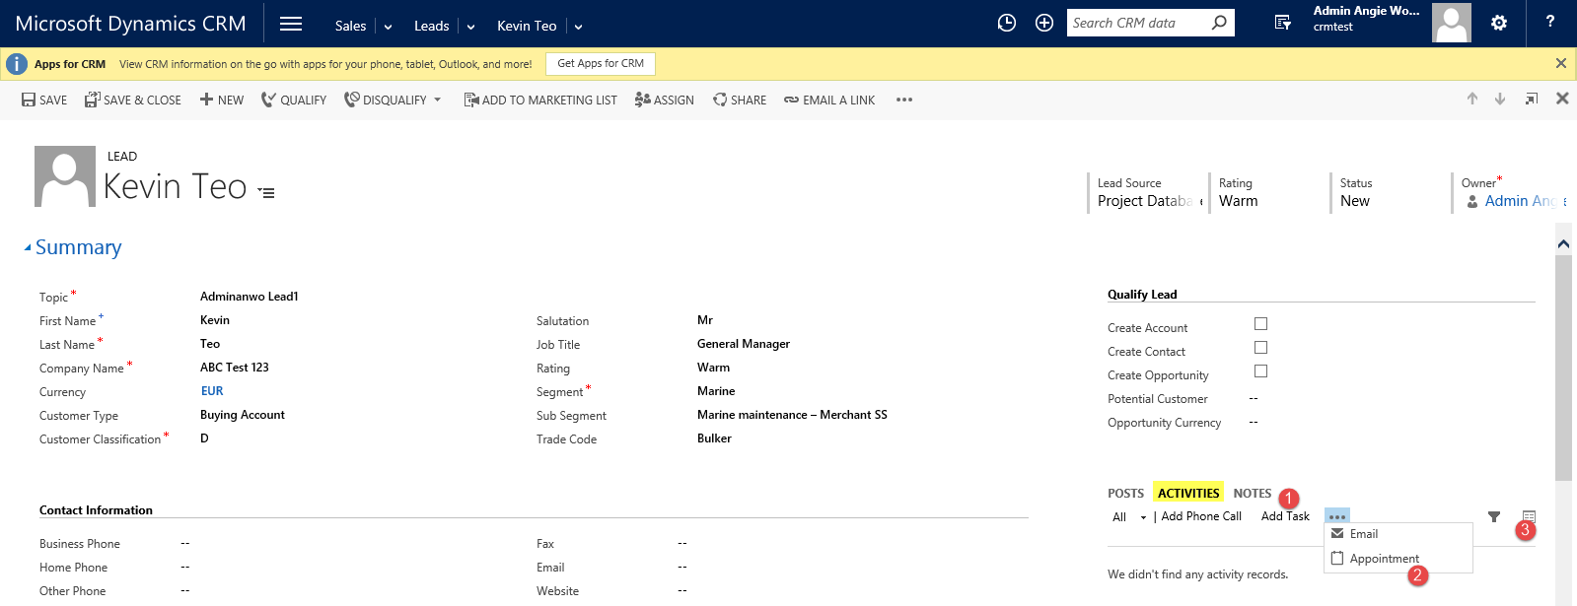

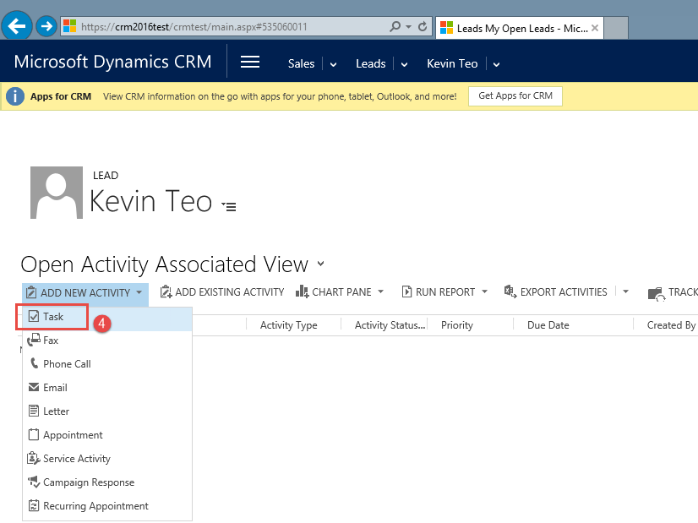

### 3.1.3 To add notes or attachment

Users can add remarks regarding the lead or add attachments via the “Notes” section

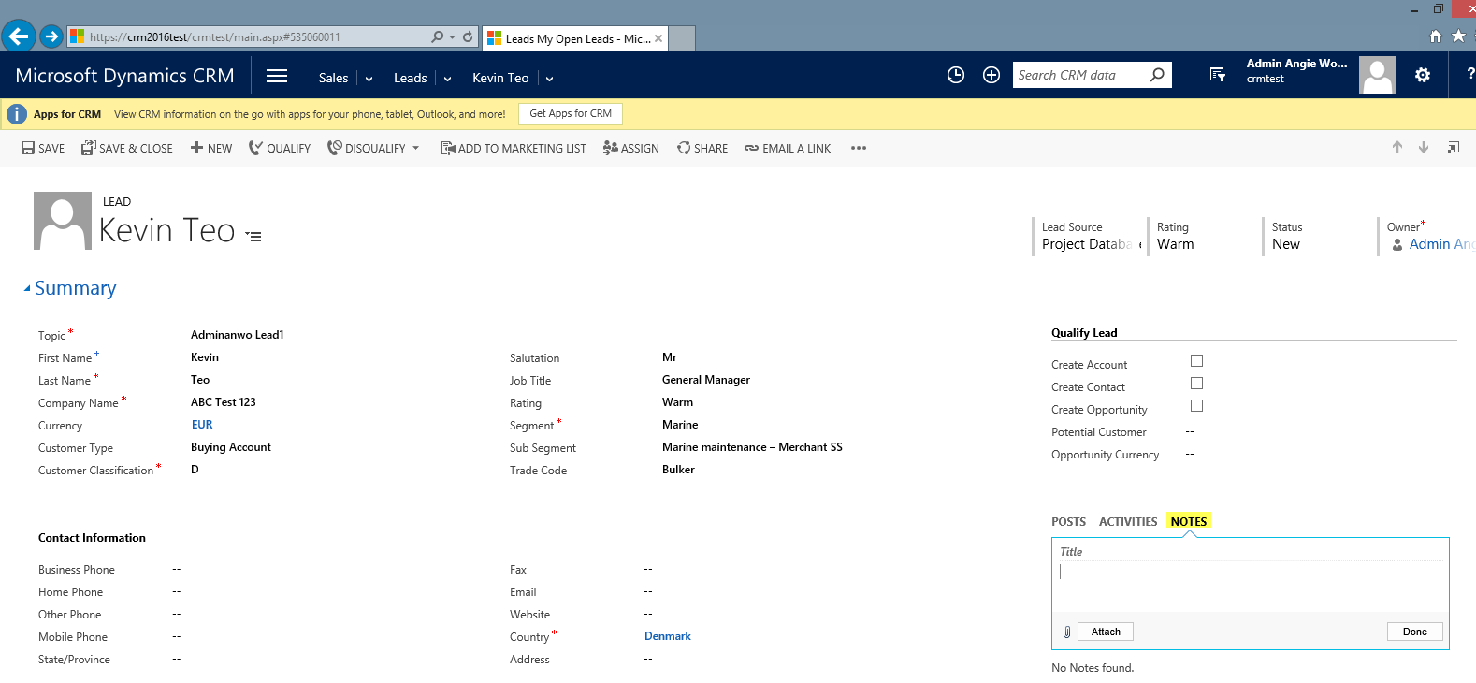

### 3.1.4 To toggle between “Summary” and “Details” section

Click the new form navigation button to shortcut to a tab within the form.

It's an ideal solultion for improved navigation of longer forms by avoiding repeated scrolling to find the appropriate section.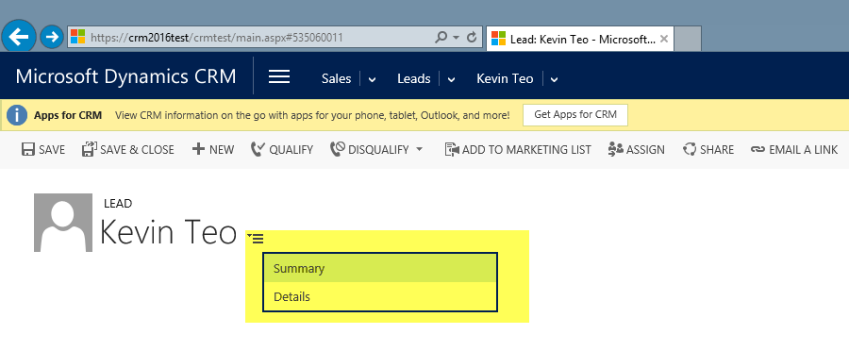

### 3.1.5 To add “Connections”

Users can create and view the relationships between records for many entities using Connect via the associate connection grid below:-

Option 1:-

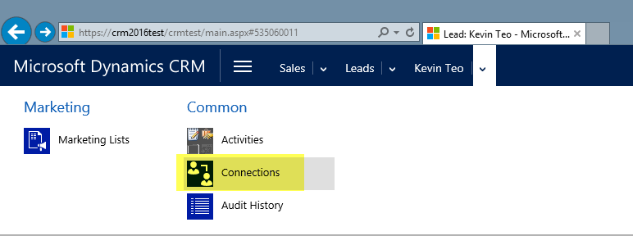

or Option 2:-

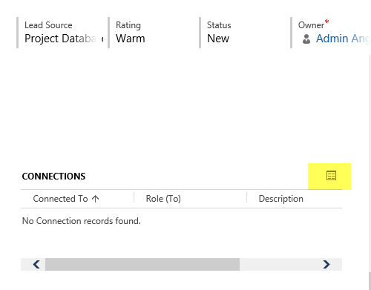

Click Connect button to connect the lead to “Me” or “To Another” with the different type of connection roles

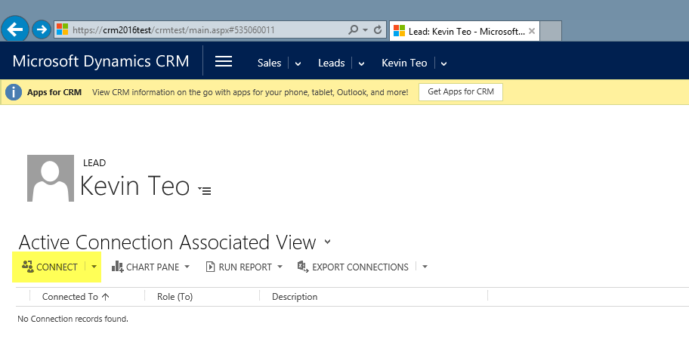

### 3.1.6 To add competitors related to the lead

User can click “+” under the Competitors grid and lookup for the existing competitor in order to add as competitor related to the lead

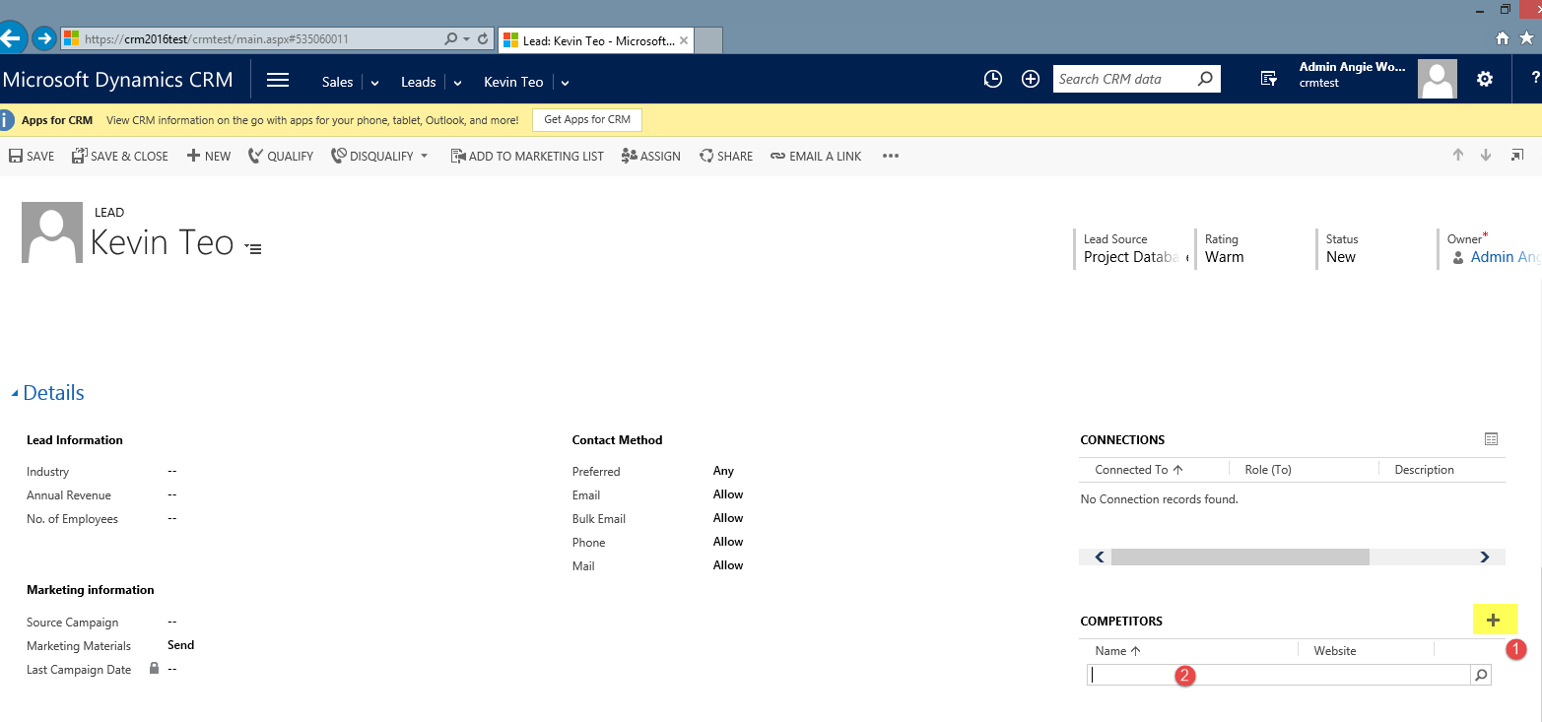

### 3.1.7 To reassign the owner of the lead

After click “ASSIGN” button, the system will default the Assign to “Me”

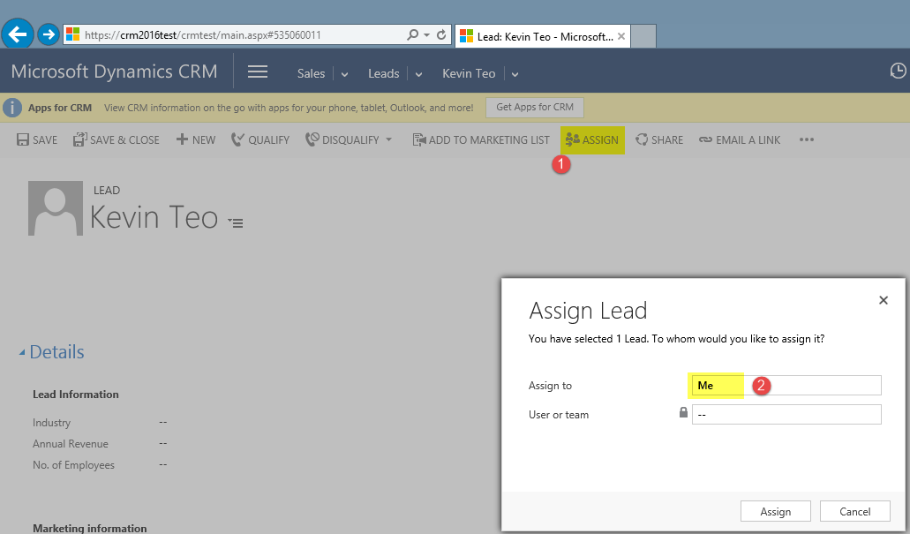

User has to click on the “Assign To” field in order for it capture “User or team” before can lookup for any user or team to assign the record to

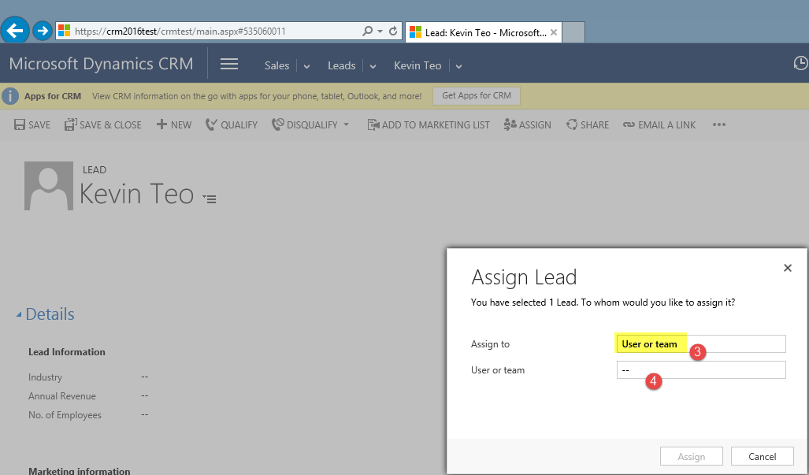

After lead successfully reassign to another owner, the system will generate the email notification. User can preview the email via the “Activities” section

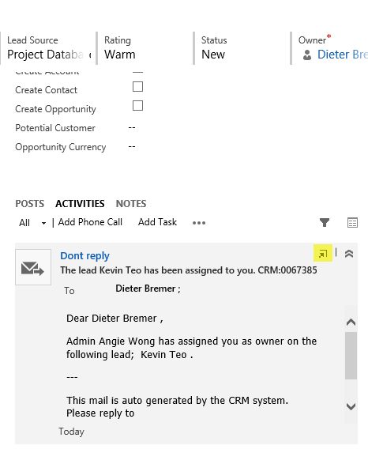

Or Open the email activity by click the “Pop out” button. User can click the X button twice in order to return to the lead record.

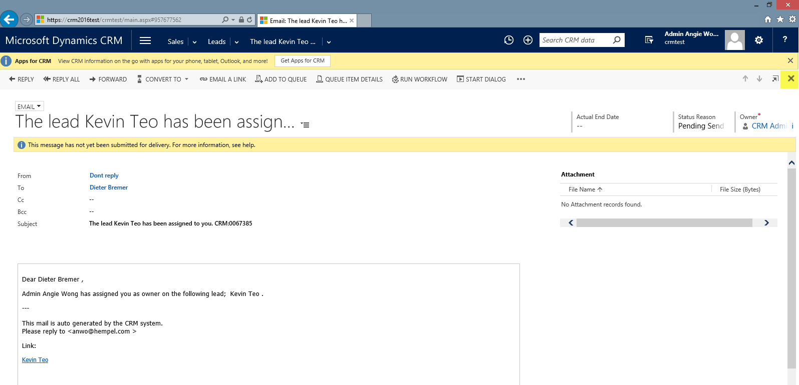

### 3.1.8 To share the lead to other users or team

User can easily share lead with the users across business units or share with a team belongs to one business unit but it can include users from other business units.

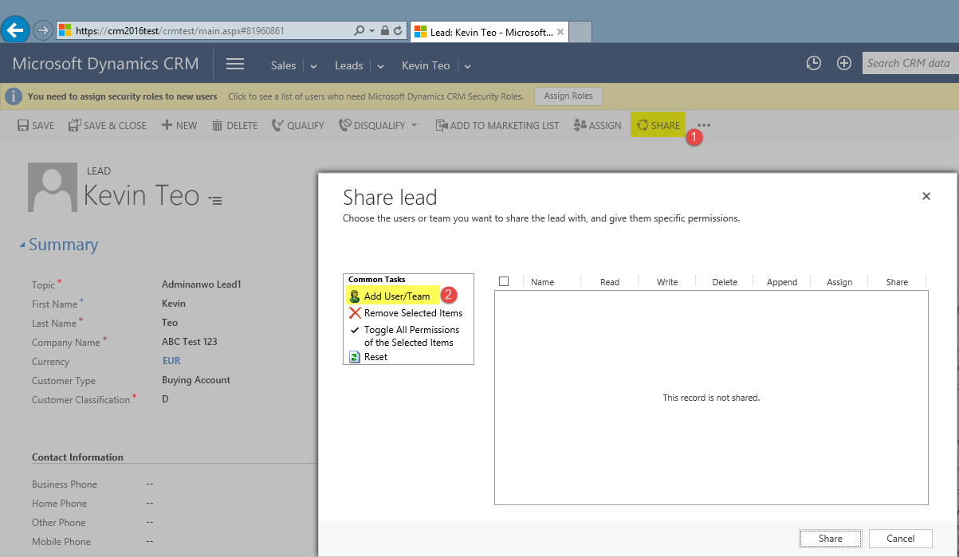

### 3.1.9 To disqualify Lead

Click “DISQUALIFY” button and select the relevant reason for lost the lead

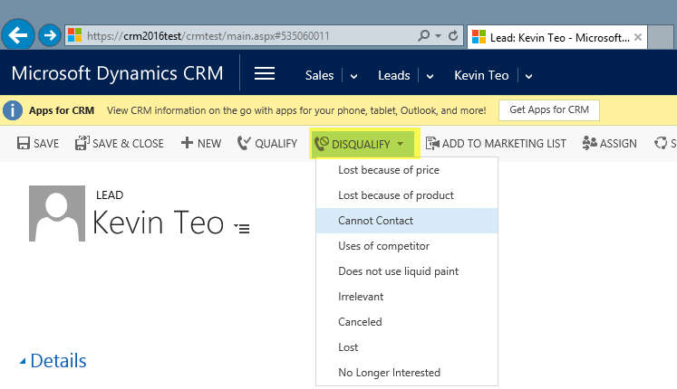

### 3.1.9 To reactivate Lead

Click the “REACTIVATE LEAD” button to activate the lead which has been disqualify

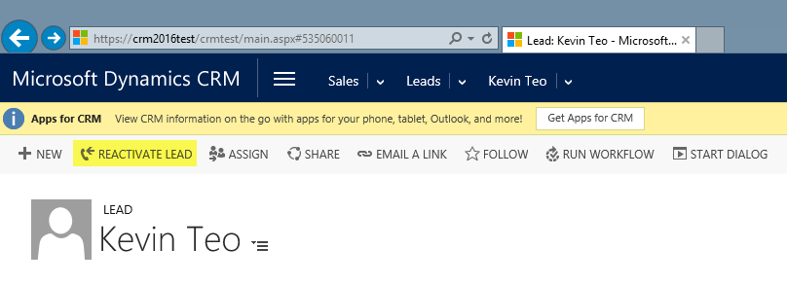

### 3.1.10 To qualify Lead

User will get the error “Lead cannot be qualified without specifying records to create”.

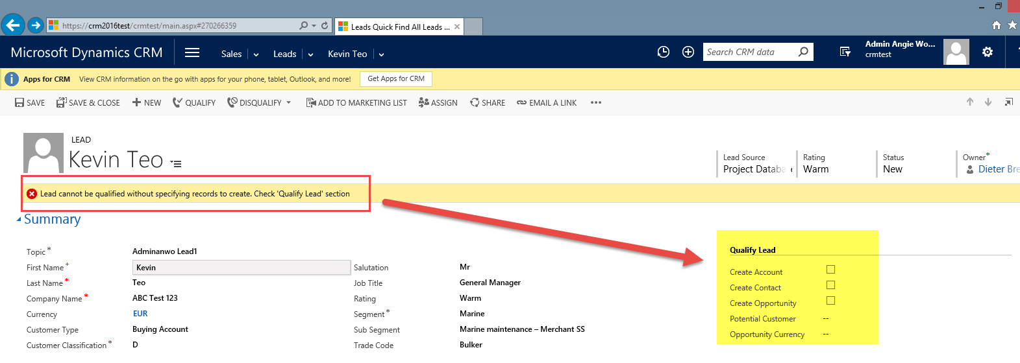

User has to either select all the checkbox to convert the lead to Account, Contact or Opportunity before click “QUALIFY” button

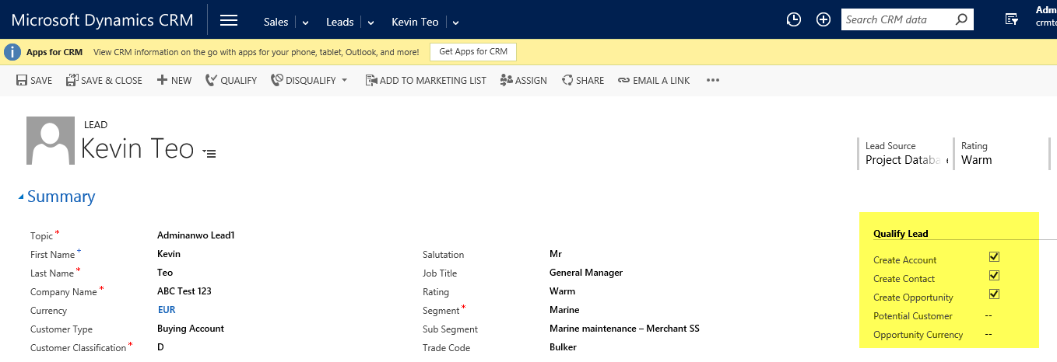

OR user can convert the lead to opportunity only by selecting the opportunity checkbox with the specify potential customer and opportunity currency and click “QUALIFY”

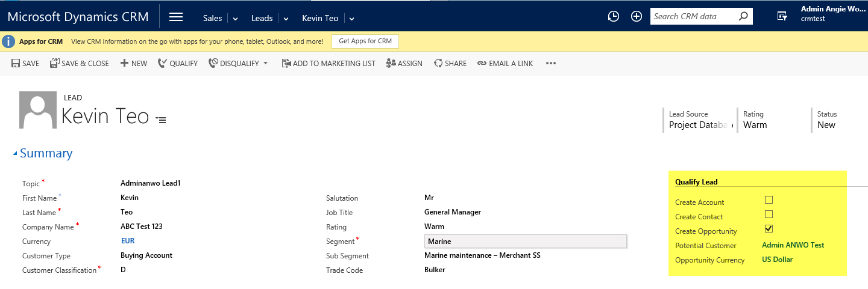

There is no option to enable for the system to automatically open the newly created Account, Contact or Opportunity, the user has to locate the records and update necessary fields accordingly.

## 3.2 Account

**An Account is a company or a group of companies.** An Account is a legal entity or well-defined sub-organisation of a legal entity (like a division or a vessel). Accounts can be: Buying Account, Owner, Specifier, Applicator, Engineer, Consultant, Distributed customer or Vessel. An Account can be part of a Parent Account (like vessel fx), which is an entity owning several accounts.

|  |  |
| --- | --- |
| **General** |  |
| Account Name | Full company (or vessel/asset) name in capital letters |
| Parent Account | Select an existing Account that owns this company / vessel / asset |
| Primary Contact | Select existing customer contact that deals with our Salesmen |
| Currency | Currency that customer will transact in |
| Phone (AX) | No spaces between city codes and phone numbers |
| Fax (AX) | No spaces between city codes and phone numbers |
| **Address** |  |
| Street 1 | Mailing Address Detail |
| Street 2 | Mailing Address Detail |
| Street 3 | Mailing Address Detail |
| City | Mailing Address Detail |
| State/Province | Mailing Address Detail |
| Zip/Postal Code (AX) | Mailing Address Detail |
| Country (AX) * | Location of company business registration |
| Phone | Main Company Line |
| Address Type | BILL TO - Invoicing Address SHIP TO - Delivery Address OTHER - Non Buying or Unknown |
| Freight Terms | Refer to Incoterms |
| Shipping Method | Select "Will Call", if unknown |
| **Local Language** |  |
| Account Name | Full company (or vessel/asset) name in local language |
| Main Phone | No spaces between city codes and phone numbers |
| Fax | No spaces between city codes and phone numbers |
| **Description** |  |
| Object ID/IMO No (AX) | Unique asset or vessel identificaton code |
| Object Surface m2 | Asset / Vessel detail |
| Object Size | Asset / Vessel detail |
| Last Opportunity Date | Date of last supply for Asset / Vessel (ie: last drydock) |
| Size Units | Asset / Vessel detail |
| Service Interval Period (months) | Expected duration between supplies for Asset / Vessel (ie: last drydock and next one) |
| Trade Code | Detailed Sub Segment |
| Next Opportunity Date | Automatically calculated based on "Last Opportunity Date" and "Service Interval Period" |
| Reminder for next opportunity | Automatic email reminder for Account Owner to follow-up on opportunity. Default is 1-year before "Next opportunity date" |
| Customer Penetration | % of total paints potential from customer that is already secured by Hempel. (Market share in a customer) |
| Customer Classification (AX) | Customer priority according to sales potential or strategic importance, refer to local classification guide |
| Potential Volume | Estimation of paints volume purchased yearly by customer (includes purchase from our competitors) |
| ASP/L | Average Selling Price per Litre (Check Potential Revenue & Potential Volume) |
| Potential Revenue | Estimation of paints VALUE purchased yearly by customer (includes purchase from our competitors) |
| GP/L | Automatically calculated based on Potential Gross Profit / Potential Volume |
| Potential Gross Profit | How much of annual Potential Revenue is Hempel's profit? |
| Potential Volume | Annual Potential Paints Consumption of a target customer Account in Volume |
| ASP/G | Average Selling Price per Gallon (Check Potential Revenue & Potential Volume) |
| GP/G | Automatically calculated based on Potential Gross Profit / Potential Volume |
| Potential Revenue EUR | Auto-converted from Base Currency |
| Potential Revenue USD | Auto-converted from Base Currency |
| Potential Gross Profit EUR | Auto-converted from Base Currency |
| Potential Gross Profit USD | Auto-converted from Base Currency |
| Potential Gross Profit CNY | Auto-converted from Base Currency |
| Description | Additional background or remarks about Account (Use notes for attachments) |
| **Preferences** |  |
| Owner | Hempel employee that created the account OR is assigned/responsible to serve the Account |
| Company No (AX) | Hempel Business Unit Code |
| Account Number (AX) | AX generated customer code |
| Synchronization Status | If yes, synchronized fields will have to be updated from AX |
| Company | If synchronized, this shows AX Account that this CRM account is linked with |
| Originating Lead | Lead source, if account originated/converted from a CRM lead |
| DW Key (AX) | AX generated |
| ERP Business Unit (AX) | Auto-generated - Hempel Business Unit Code |
| Bill To Account | AX CRM Synchronization Parent account |
| Company | Auto-generated - Hempel Business Unit |
| Credit Limit (AX) |  |
| **Contact Methods** |  |
| Preferred | How may Hempel contact the customer? |
| **Marketing Information** |  |
| Send Marketing Material | Include in Campaigns? |
| Last Date included in Campaign | Auto-generated |
| **Notes & Activities** |  |
| Activities | All related activities |
| Note | Time-stamped and user-idenfitied remark. Attachments allowed |
| **Contacts** | All contacts directly linked with this Account |

### 3.2.1 Create Account

#### 3.2.1.1 To create a new account using complete form, click on “New” in the “Accounts” section

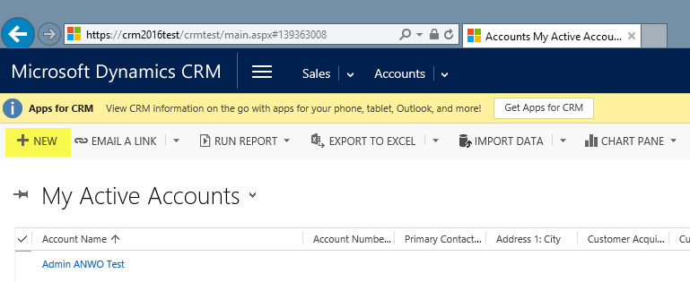

Please note, that all fields, which are marked with a red star, are mandatory to be filled out.

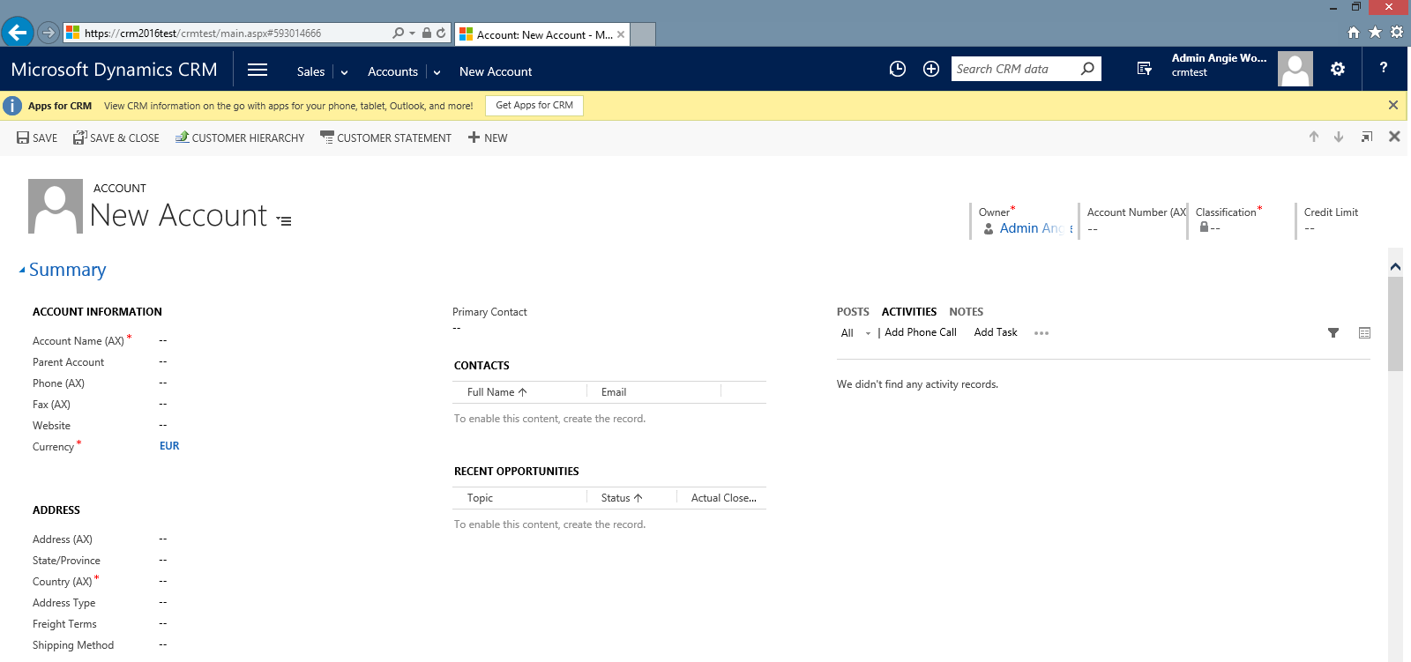

#### 3.2.1.2 To create account using simple form, click on Quick Create Items -> “Account” section

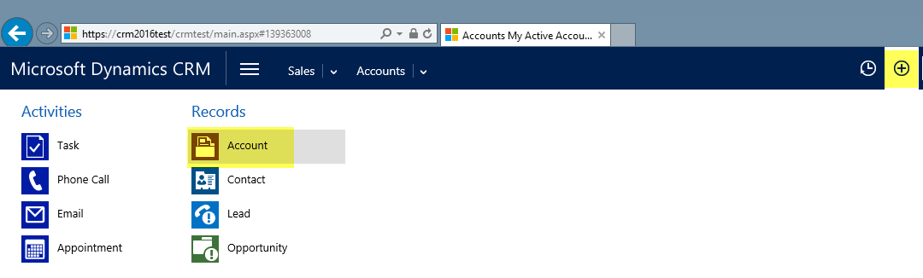

Please note, that all fields, which are marked with a red star, are mandatory to be filled out.

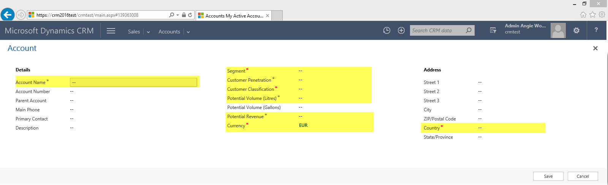

### 3.2.2 To assign Primary Contact

User can lookup for primary contact or click “New” to create the primary contact for the related account

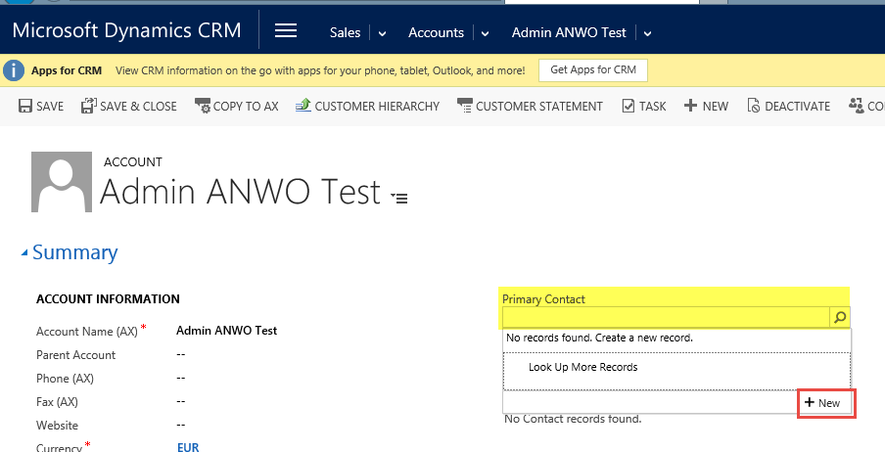

### 3.2.3 To create associate Contact

User can on the “+” sign in order to add new associate contact using the quick create contact form

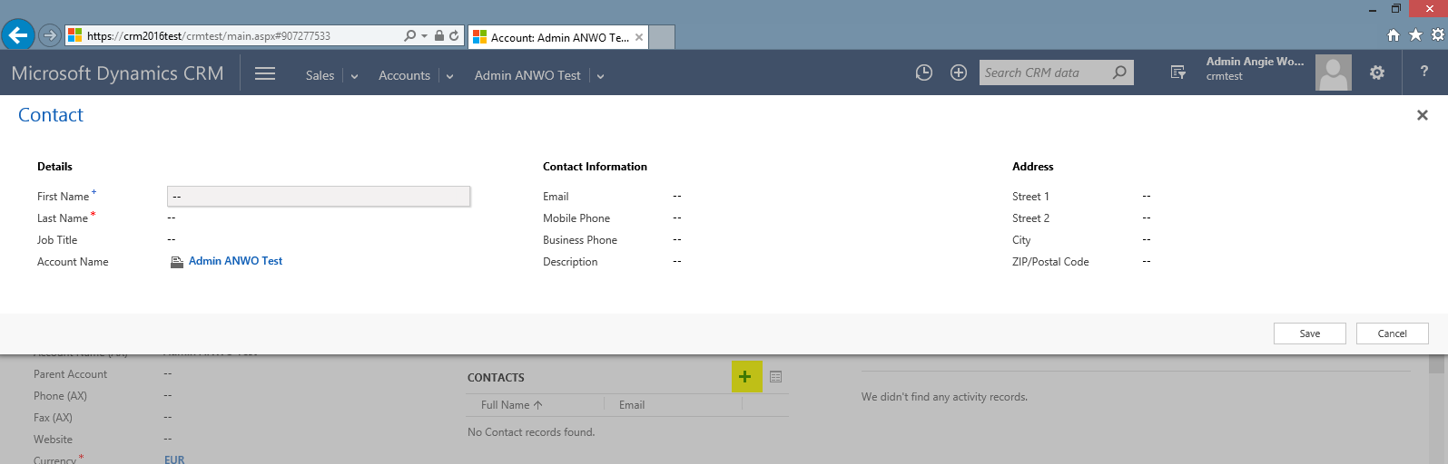

### 3.2.4 To create associate Opportunities

User can on the “+” sign in order to add new associate opportunity using the quick create opportunity form

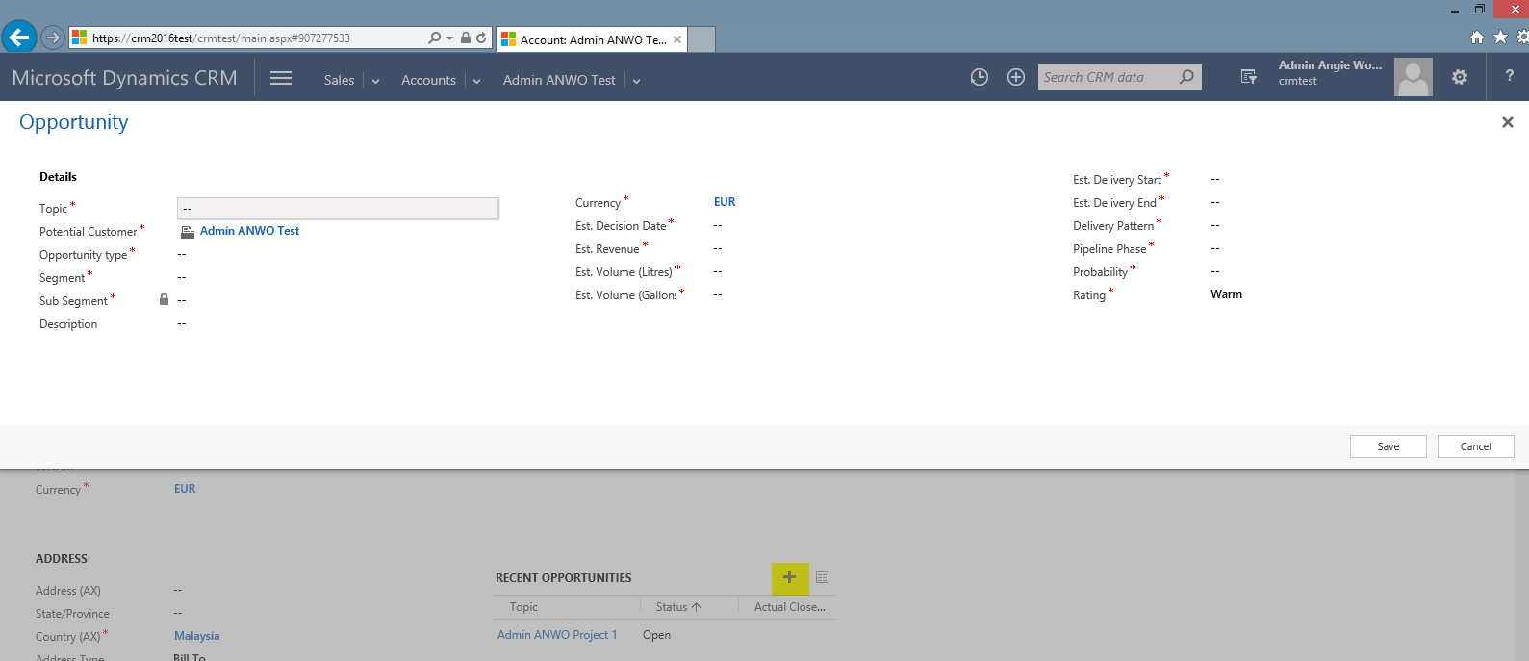

### 3.2.5 To toggle between account form section

Click the new form navigation button to shortcut to a tab within the form.

It's an ideal solultion for improved navigation of longer forms by avoiding repeated scrolling to find the appropriate section

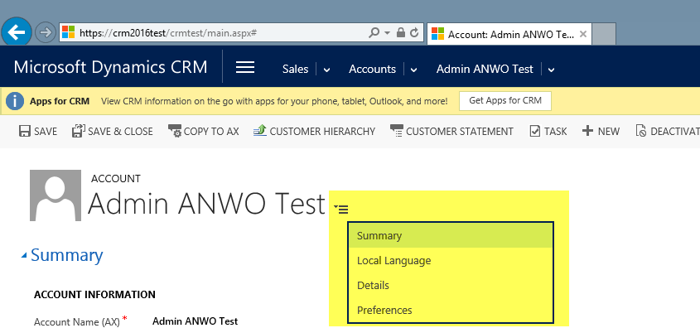

### 3.2.6 To create sub account

Under the “Sub Accounts” section, user can click the “+” to lookup for existing account as sub account or click “+New” to create new sub account

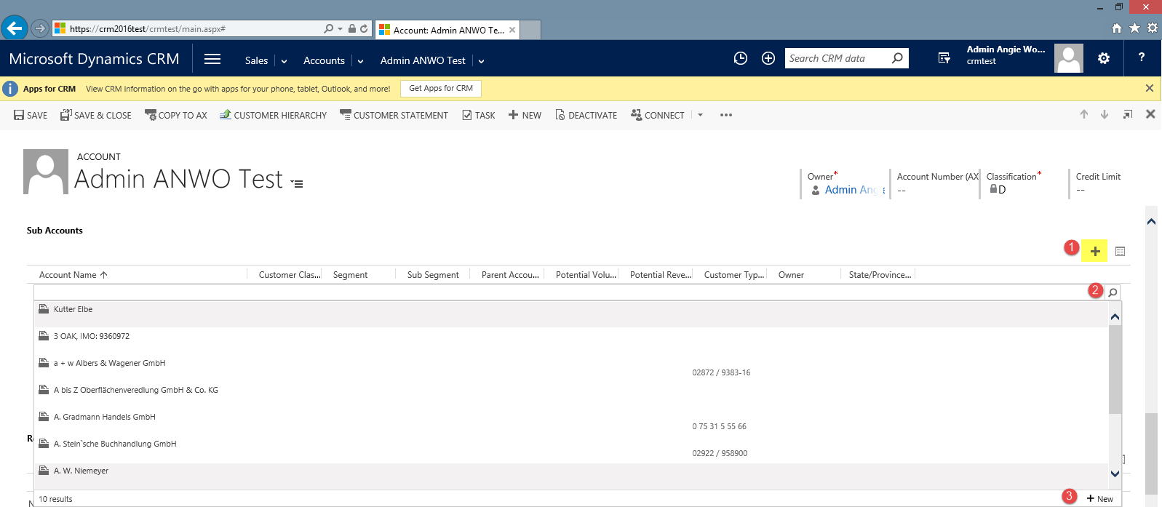

### 3.2.7 To view associate complaints

User can view the associate complaints via “Recent Complaints” grid

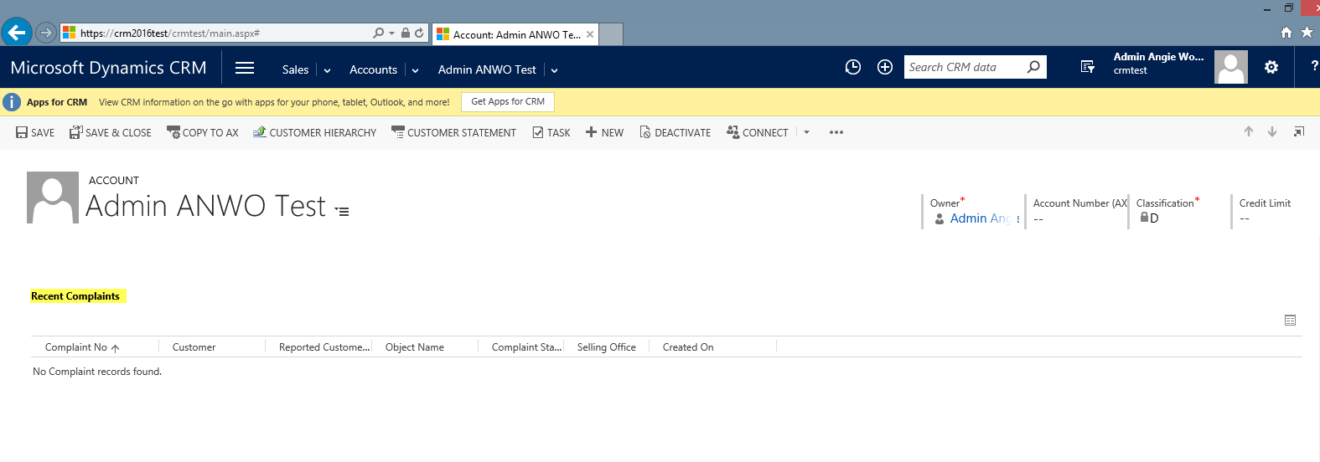

### 3.2.8 To add “Connections”

User can create the relationships between records for many entities using “CONNECT” button

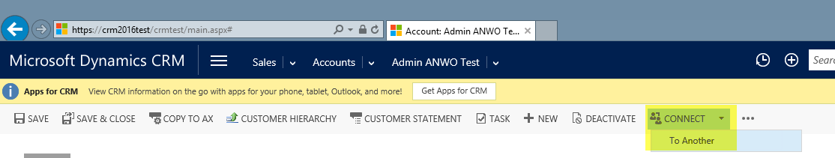

### 3.2.9 To view related connections

User can view the relationships between records for many entities via the Connections grid

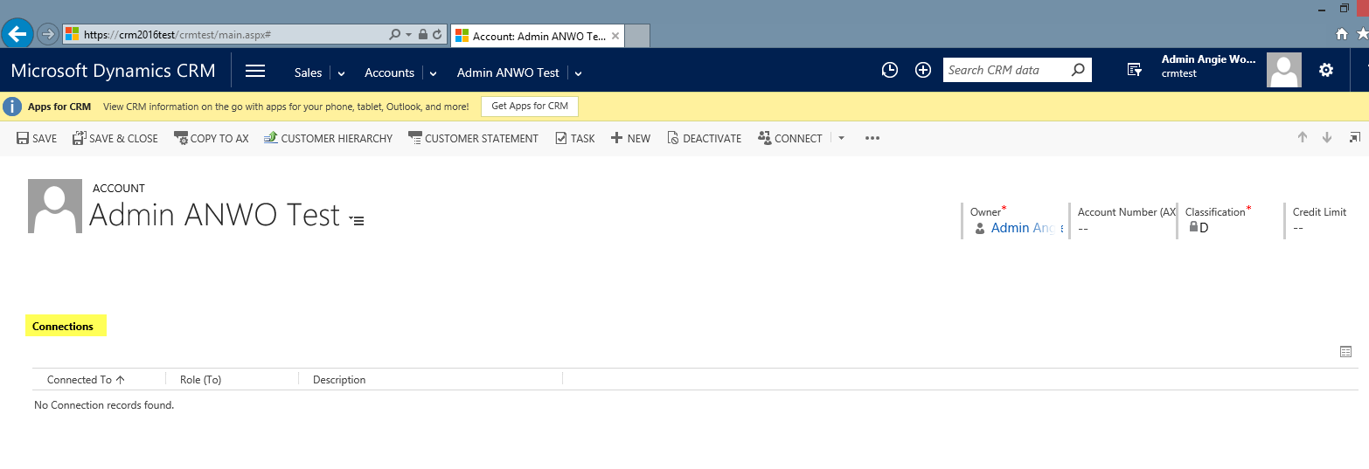

### 3.2.10 To create associate Task or mark the task activity as “Completed”

User can click the “TASK” button to create new task

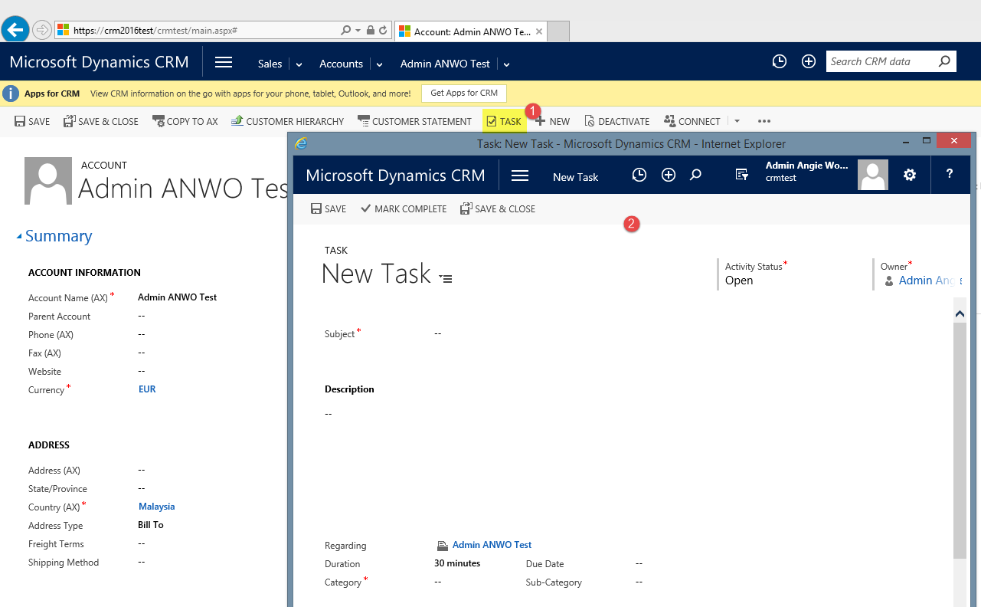

The task will be listed under “Activities” section, the user can click “COMPLETE” to mark the task activity as completed or pop out the activities to make necessary update on description etc.

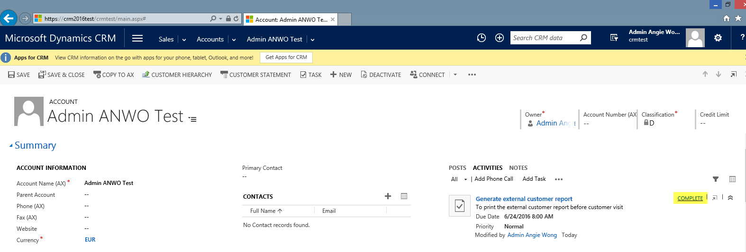

### 3.2.11 To create associate appointment

User can click the “Appointment” under Activities section to add new appointment

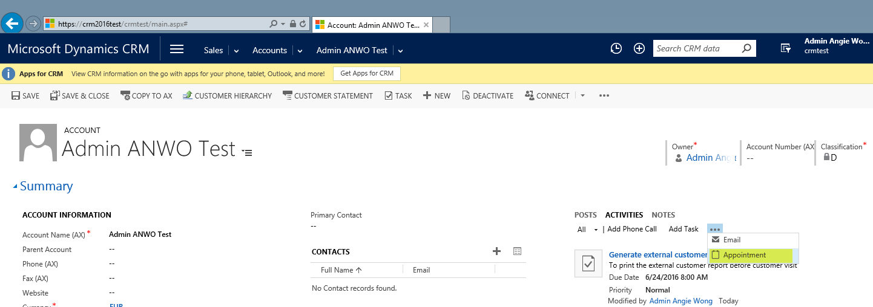

### 3.2.12 To COPY the CRM account to AX

User has to ensure the Address Type and Sub Segment selected aside from the mandatory fields before click “COPY to AX” button. With the “COPY to AX” dialog, user will download the new account requisition form and click Submit in order for the CRM account synchronize to AX after job run.

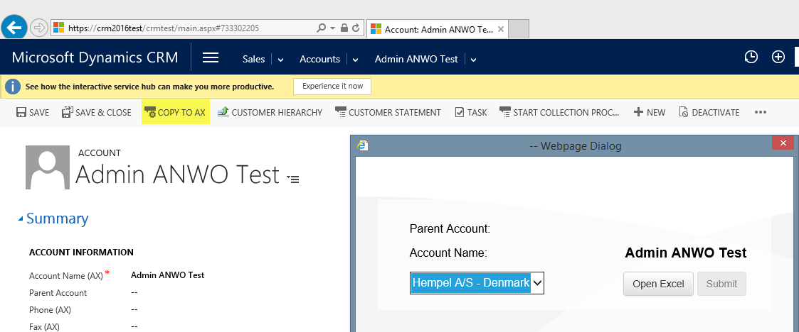

### 3.2.13 To share the account

User should click on the ellipse button in order to select the “Share” function to share account with the users across business units or share with a team belongs to one business unit but it can include users from other business units.

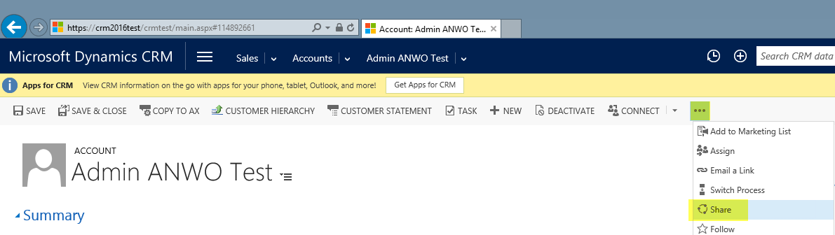

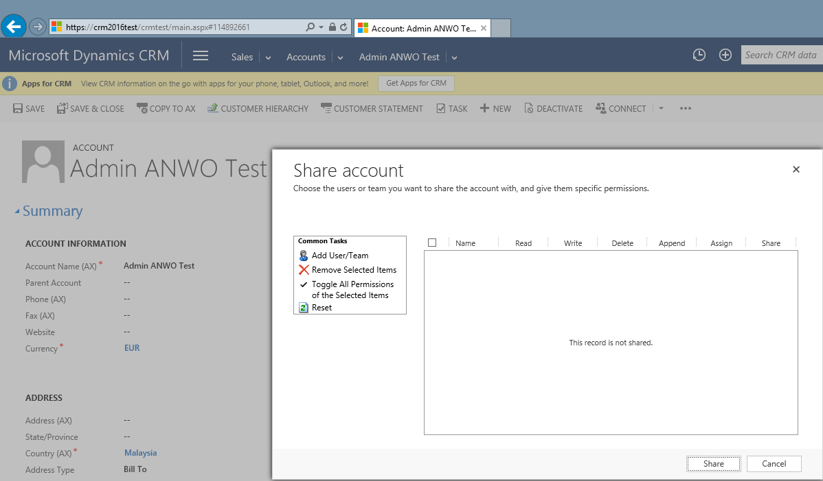

### 3.2.14 To print Customer Hierarchy

User can click “CUSTOMER HIERACHY” button in order to view the custom hierarchy which capture the parent child accounts, opportunities with status and connection.

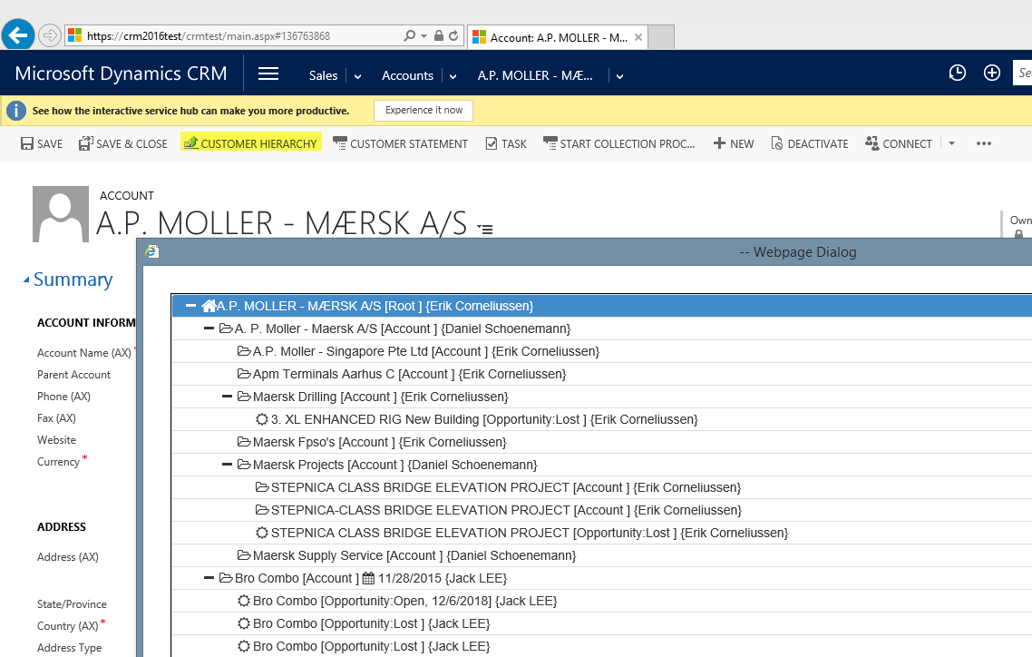

### 3.2.15 To generate reports

User can click on the ellipse to select “Run Report” option in order to run Internal Customer Report, External Customer Report or DockEye Report.

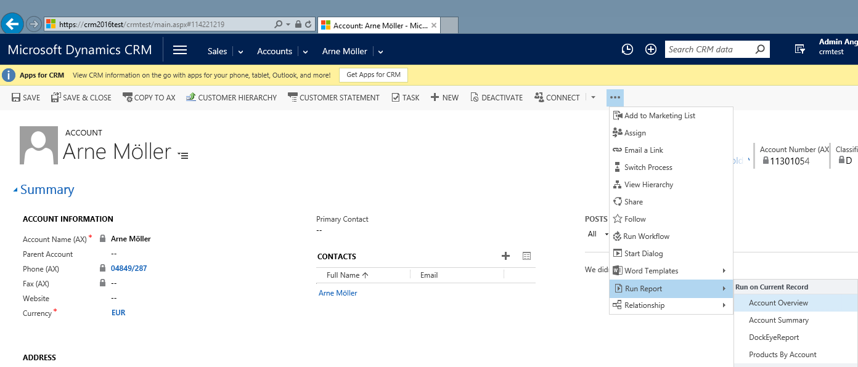

### 3.2.16 To view the out of box hierarchy where it is showing the parent and child account hierarchy

This allows a user to ‘see’ where a particular record fits in the within the parent/child relationship for a given entity. For example, an Account record in CRM could have a ‘Parent Account’ or many ‘Sub-Accounts’ or child accounts. It is now possible to display these relationships as a hierarchy visualization.

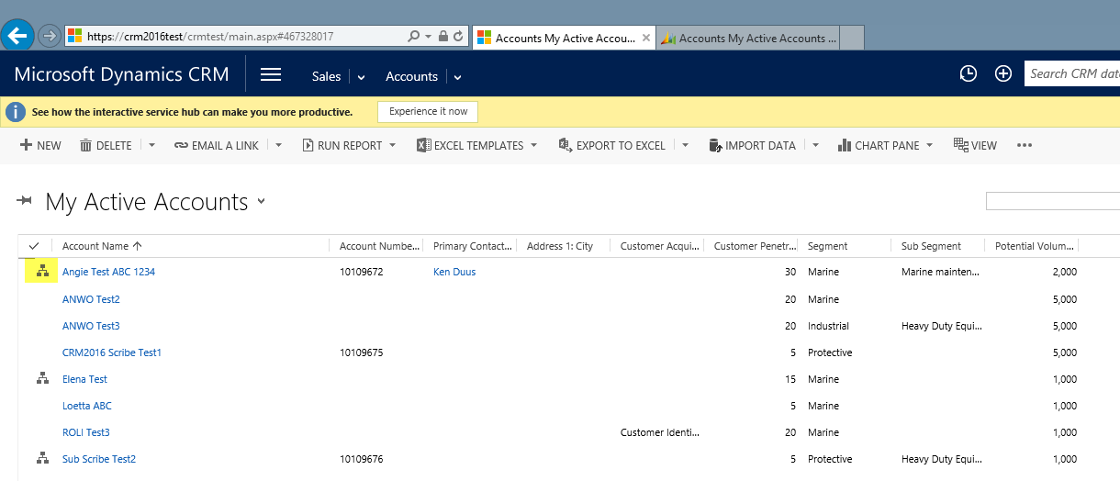

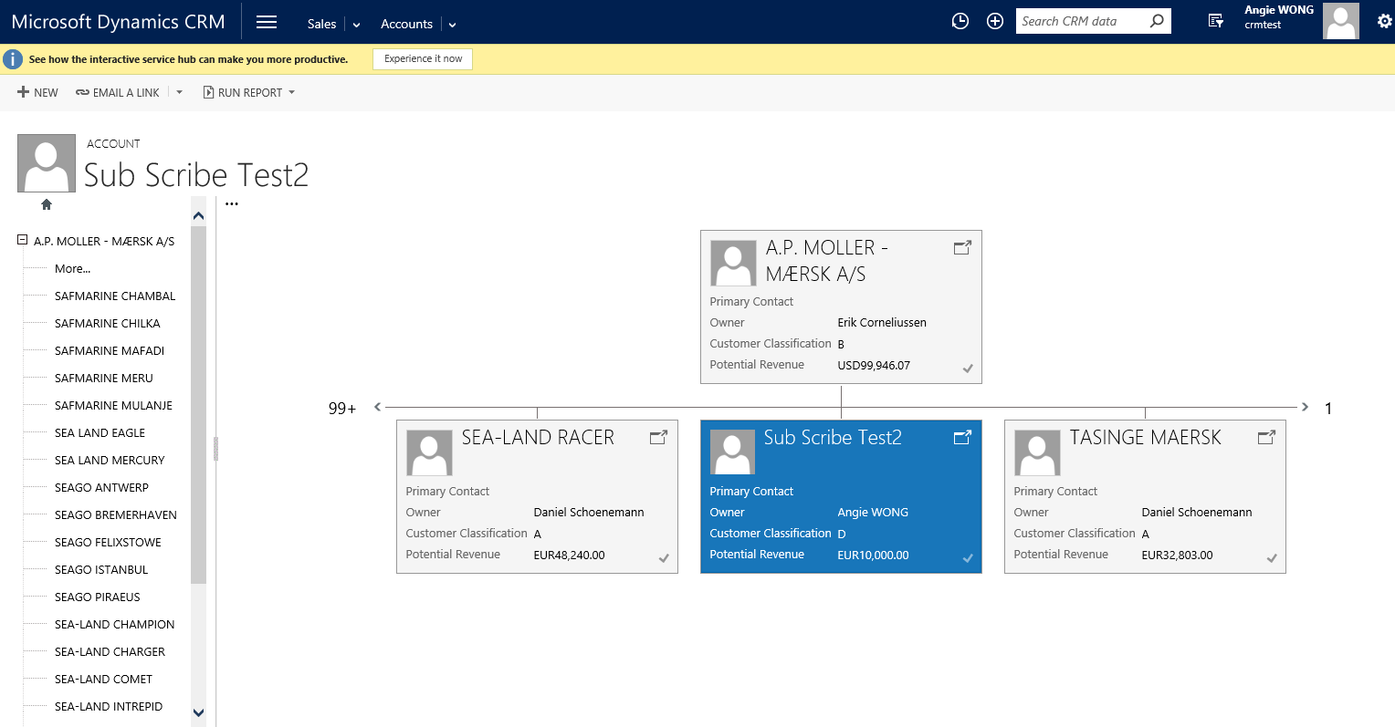

### 3.2.17 To pin the default view that always needed

User can click the pin in order to set the view as the default view.

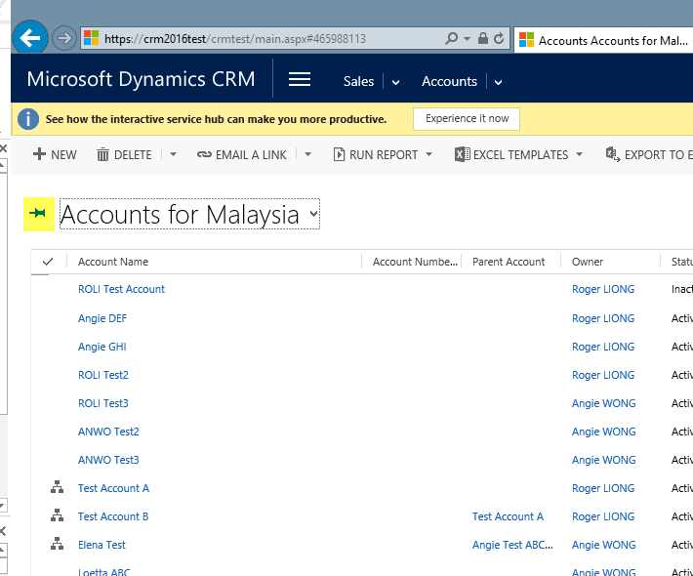

### 3.2.18 To export data to excel

User can choose any of the option from the “Export to Excel” drop down list to export the data from CRM to Excel

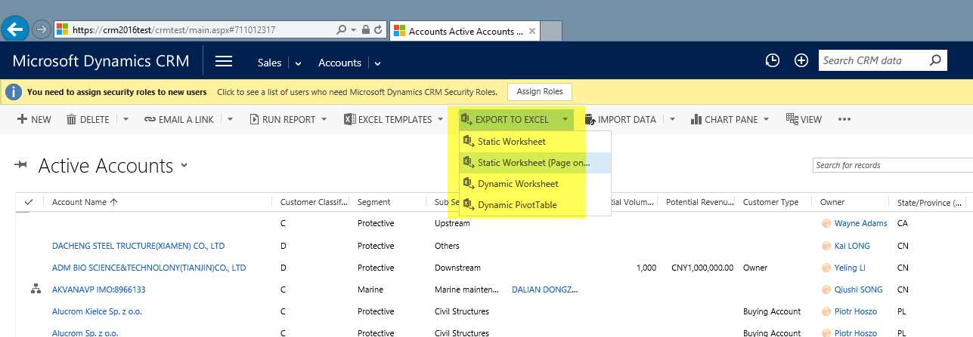

### 3.2.19 To access the document library folder for accessing generated Sales Invoices, Sales Quotation, Sales Orders or upload any documents related to the account

The system will automatically created the document library folder upon new account creation. User can access via the associated grid by click “Documents” entity

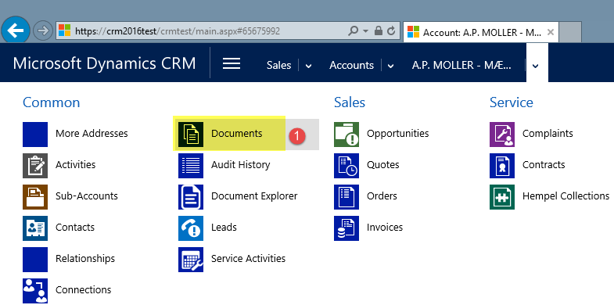

For those accounts that already synchronize with AX, the system will capture the archiving sales invoice, sales quotation and sales orders. User can just navigate to the folder to locate the needed documents. User can also click the “Add” button to add new document related to Account for example Agreements

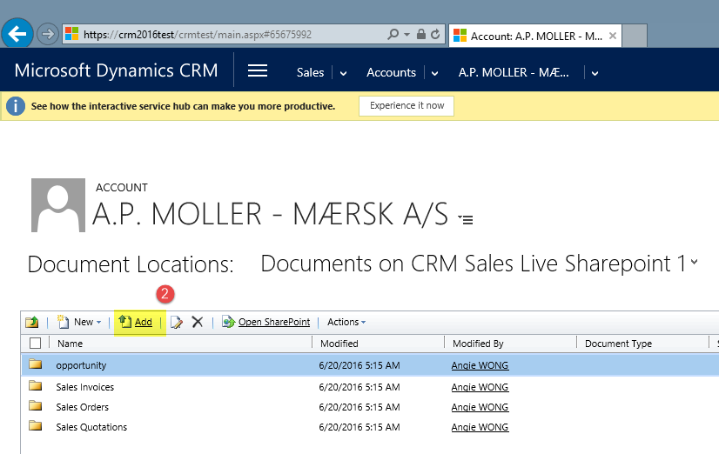

User has to browse for the file and click OK in order to upload the file to sharepoint

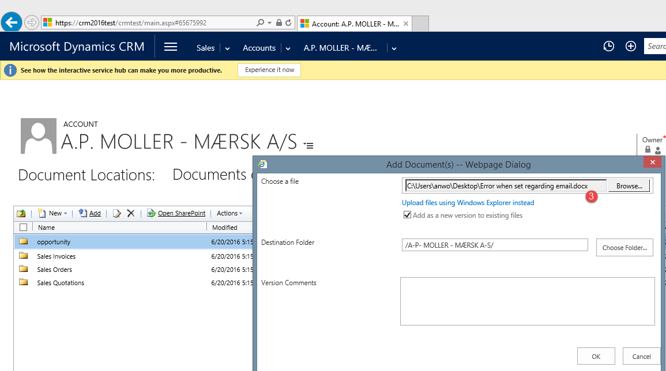

Before user can check-in the file, the user need to fill in some mandatory fields with relevant data.

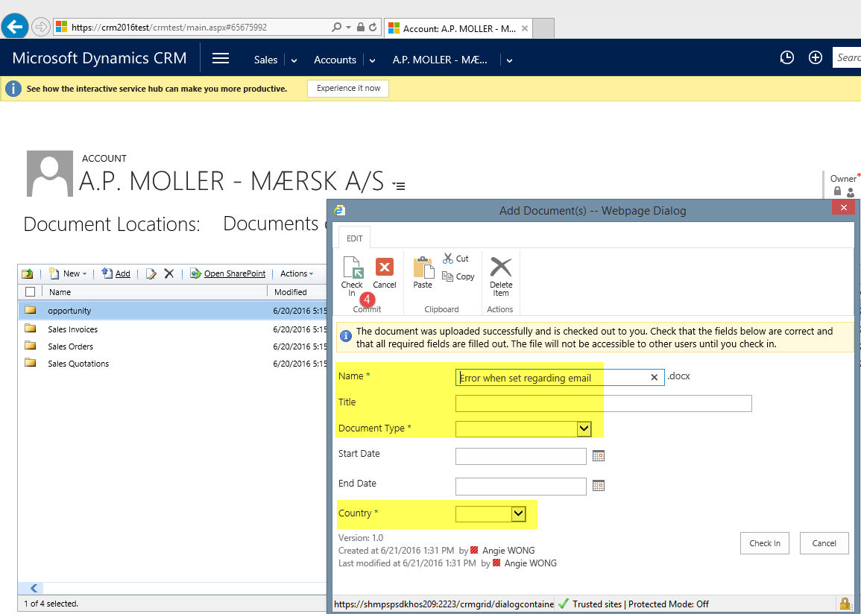

### 3.2.20 To view the parent child document structure and access the related document folder

User can access the parent account in order to locate the sub account document folder directly via the “Document Explorer” view

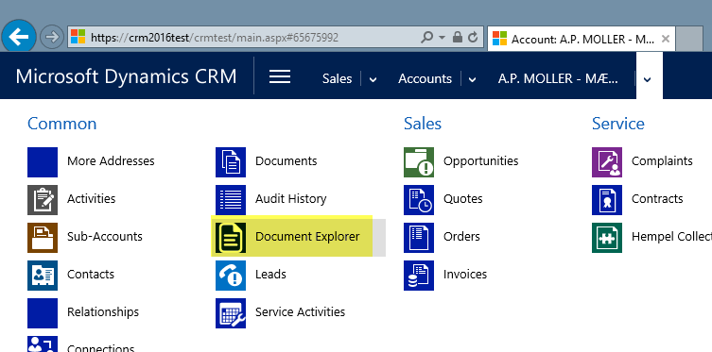

User can select any sub account in order to explore it in Sharepoint and upload any documents

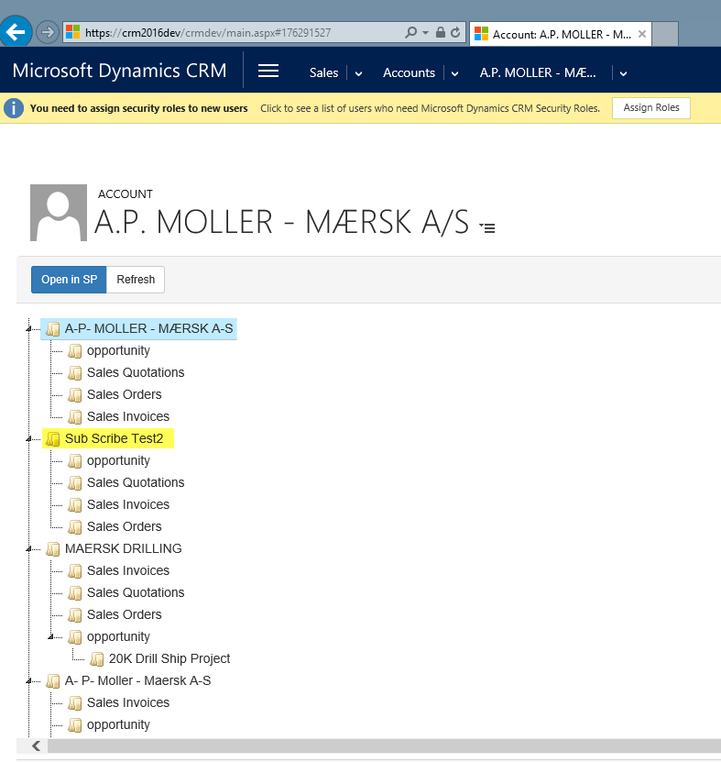

## 3.3 Opportunity

**An Opportunity is a project, dry dock or a contract (i.e. an annual supply contract) with a start and finish date.** When possible, an Opportunity must belong to the BUYING ACCOUNT. If other Accounts are relevant for an Opportunity (i.e. a Specifier or Sub-contractors) these are linked to the OPPORTUNITY via the function “relationship”. To create a new Project click on “New” in the “Opportunities” section:

|  |  |
| --- | --- |
| **General** |  |
| Opportunity type* | There are 7 types of opportunities business process where each phase having different activities: 1) Marine Maintenance Contract  2) Marine Maintenance Project  3) Marine New Building  4) Protective Maintenance  5) Protective New Building  6) Decorative New Building  7) Industrial – Heavy Duty Equipment – New Building  If the opportunity doesn’t below to any types listed above, you can set as “Not Defined”. |
| Topic* | Name of the project. Has to be in English and decriptive following naming guidelines in the CRM Manual |
| Topic Local Language | Name of the project in your local language. This is not mandatory and only to be used in case English version (Topic) is not enough |
| Opportunity Category* | Use "Project" if it is a normal project Opportunity and only use Strategic and Baseload in the following cases: Strategic if you need to follow this Opportunity for strategic reasons and Baseload if is it a yearly contract with ongoing delivery you want to follow in CRM |
| Potential Customer* | Bill-To Account, where possible |
| Currency* | Expected order currency |
| Country of Decision Maker | If the projects have different stakeholders and you want to track the country of the Decision Maker (could be a ship owner of government institution) |
| **Forecast Information** |  |
| Est Revenue* | If you win this Opportunity what is your best guess about estimated revenue for Hempel. |
| Est Decision Date* | When you expect the customer will tell you if you get the contact |
| Pipeline Phase | "New" = you just heard about the project, "Quote Sent" = you have prepared and sent the quote/spec, "Negotiation" = you have been shotlisted and are negotiating final details and maybe only few competitors left, "Secured" = customer has confirmed that you will receive the order. |
| Probability% * | What is your best guess of chance of winning the project. Suggestion: 25%=Qualified, 50%=Quoted, 100%=Secured/Executed |
| Rating * | "Hot" = you have weekly activities related to the project, "Warm" = you have monthly actvities related to the project, "Cold" = nothing happening right now related to the project |
| Est Volume (L) * | If you win this Opportunity what is your best guess about estimated Volume for Hempel (will automatically be calculated into Gallons in the next field) |
| Est Volume (Gallons) * | If you win this Opportunity what is your best guess about estimated Volume for Hempel (will automatically be calculated into Litres in the next field) |
| Est Delivery Start* | When we expect to start supplying paint. |
| Delivery Country | If delivery is in another country than you are located in |
| Est Delivery End* | When we expect to finish the paint supply. |
| Delivery State/Province | Enter the related State/Province |
| Delivery Pattern* | Single Delivery (all at once) Even over Delivery period (evenly distributed)  Forward Heavy (most in the beginning) Back Heavy (most at the end) |
| **Preference** |  |
| Owner * | Sales Person who respond to follow up on the Opportunity |

### 3.3.1 Create Opportunity

#### 3.3.1.1 To create a new opportunity using completed form, click on “New” in the “Opportunity” section

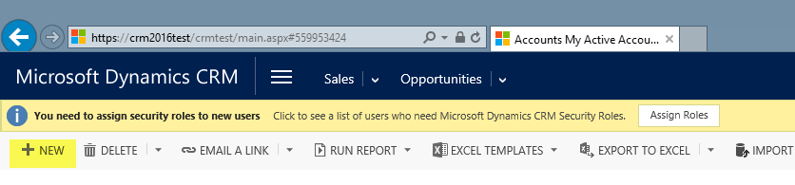

Please note, that all fields, which are marked with a red star, are mandatory to be filled out.

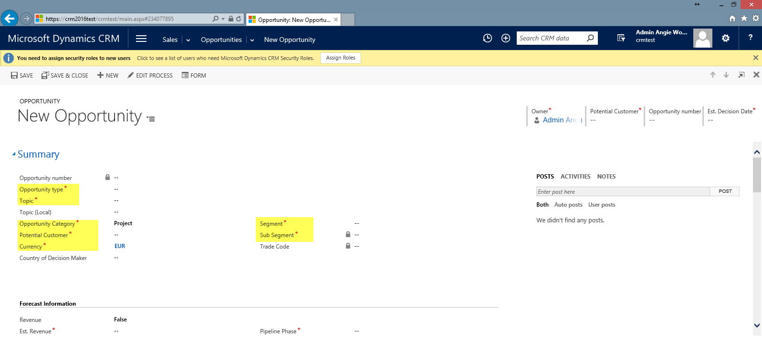

#### 3.3.1.2 To create opportunity using simple form, click on Quick Create Items -> “Opportunity” section

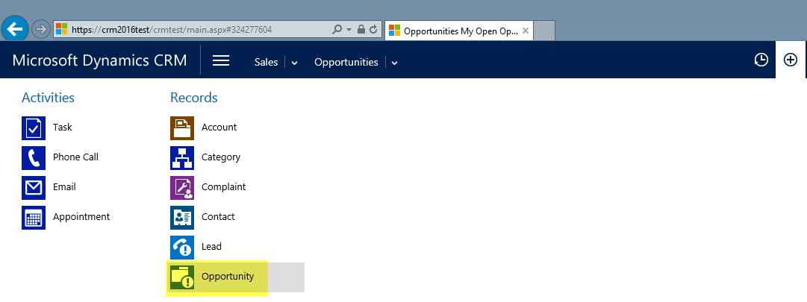

Please note, that all fields, which are marked with a red star, are mandatory to be filled out.

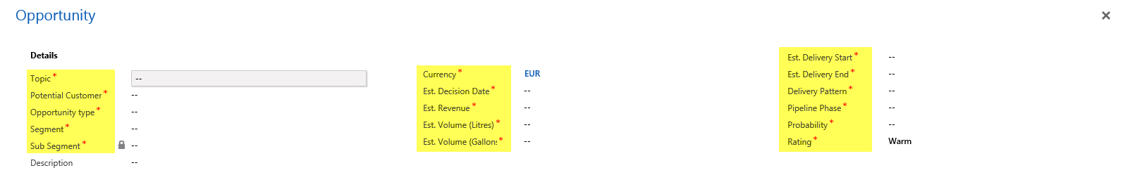

### 3.3.2 To toggle between opportunity form section

Click the new form navigation button to shortcut to a tab within the form.

It's an ideal solultion for improved navigation of longer forms by avoiding repeated scrolling to find the appropriate section

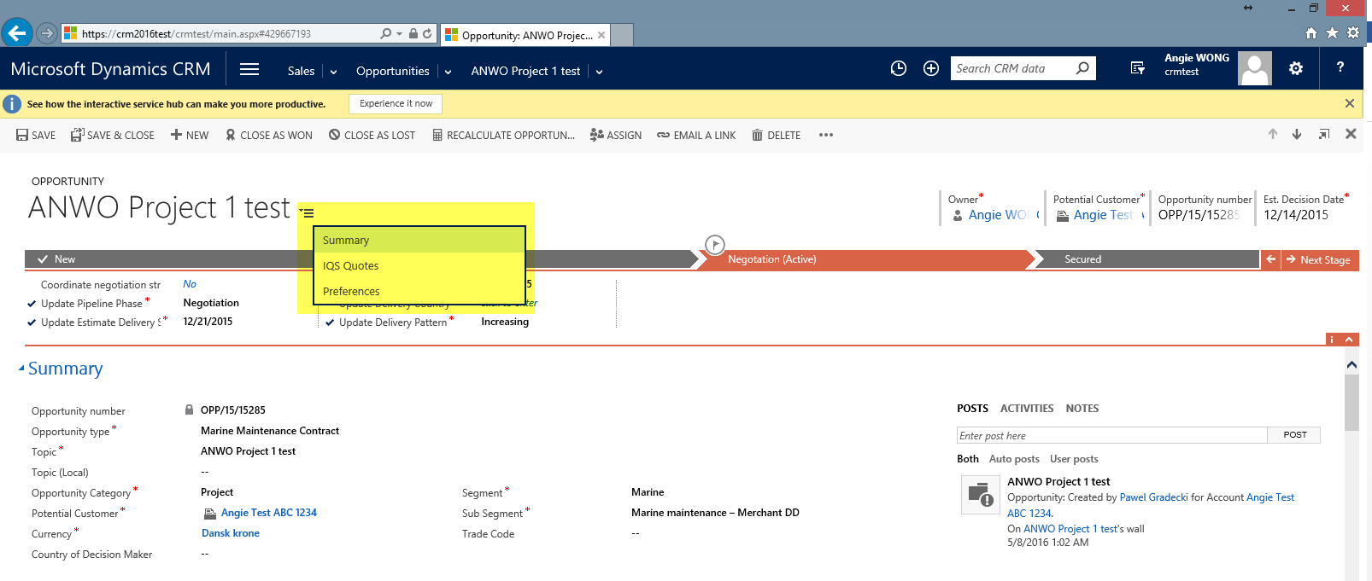

### 3.3.3 To move between Stage on opportunity business process and updating field under each Stage

Opportunity stages define where a project is in the project cycle. Each stage may have distinct activities associated with them. User can click “Next Stage: in order to move between Stage on each opportunity business process. The pipeline phase will automatically change once the Stage is change.

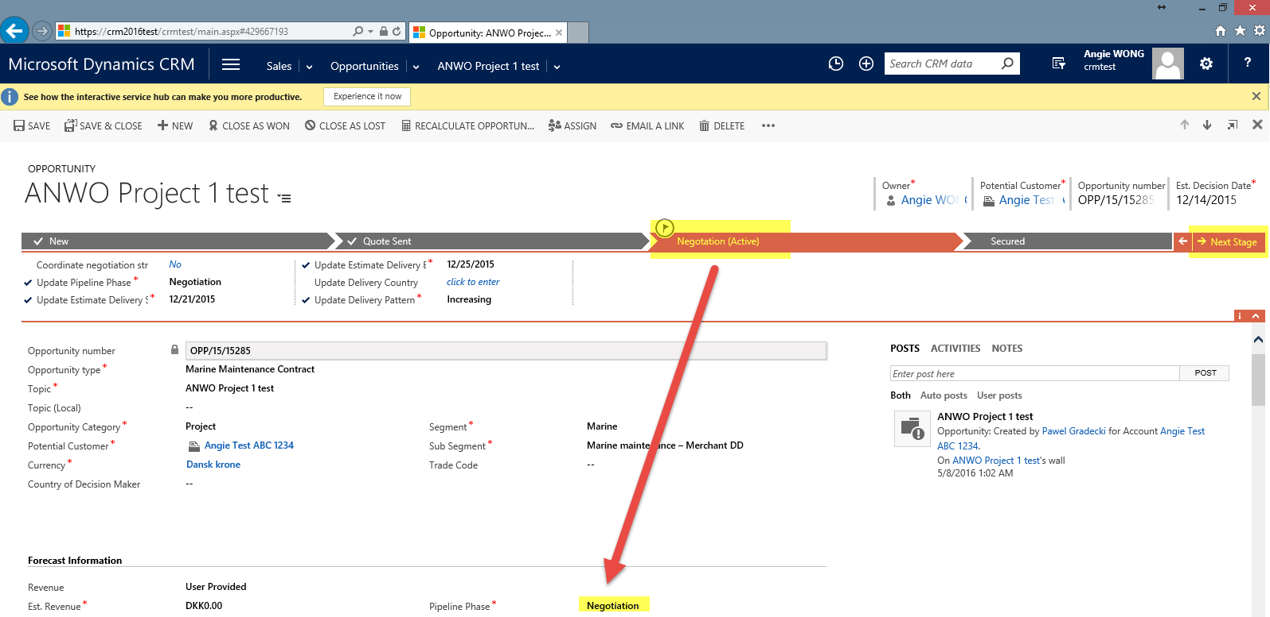

Updating of certain fields on each Stage will automatically update the fields under the opportunity form. For example:-

Pipeline Phase, Estimate Delivery Start Date, Estimate Delivery End Date, Delivery Country and Delivery Pattern

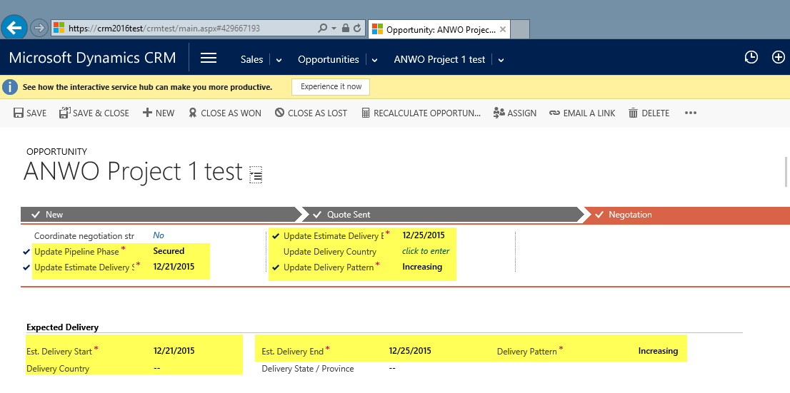

### 3.3.4 To add the Contact involved for the project

User can click “+” under the Contact grid which allows you to search contacts in the database and then assign them a role: Champion, Decision Maker, Economic Buyers, End User, Influencer, Stakeholder and Technical Buyer.

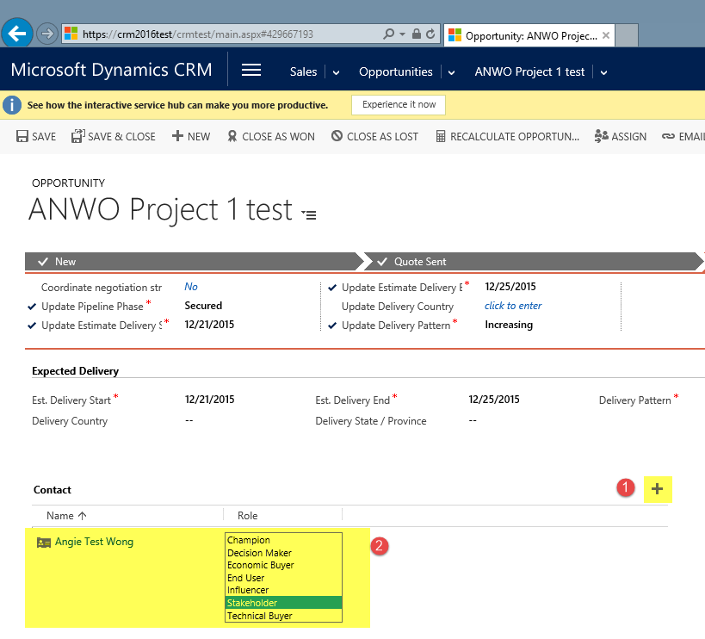

### 3.3.5 To view the Pipeline Phase History Time Stamp

User can view the pipeline phase history time stamp via the “Pipeline Phase History (Opportunity) grid”. The grid currently showing only 4 records per page, user has to next -> to move to next page

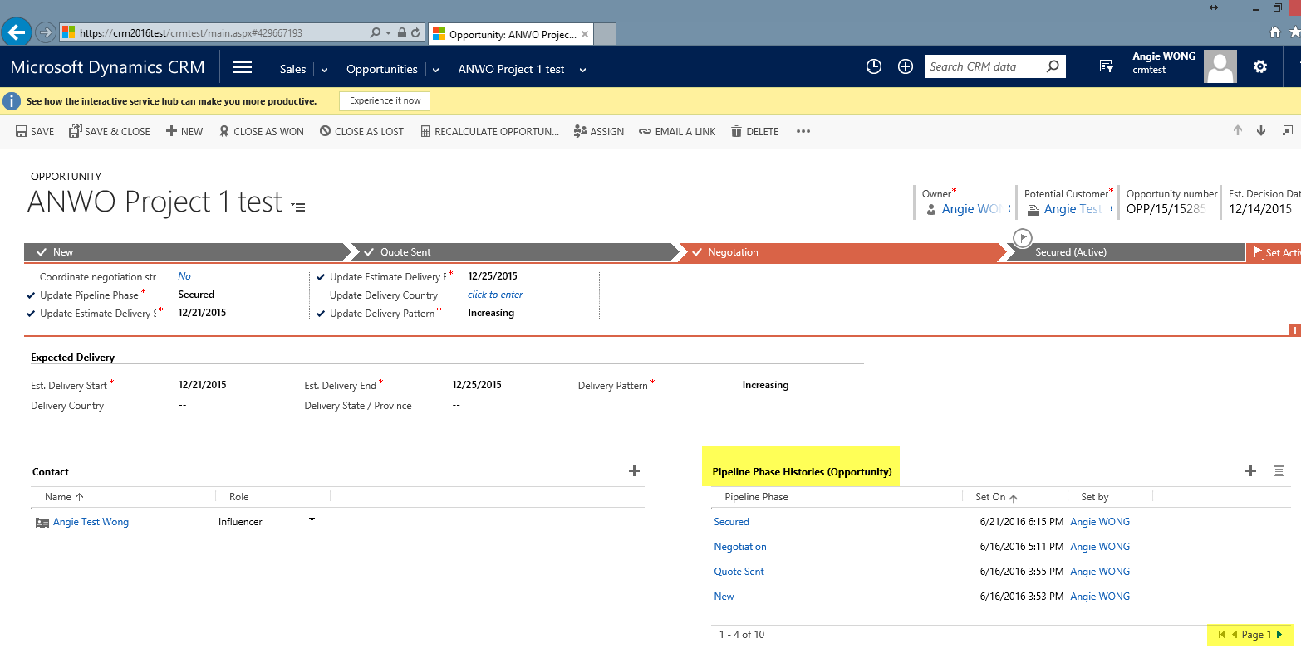

### 3.3.6 To add competitors

User can click the “+” to lookup for the competitor list and add it as competitor involved for the project.

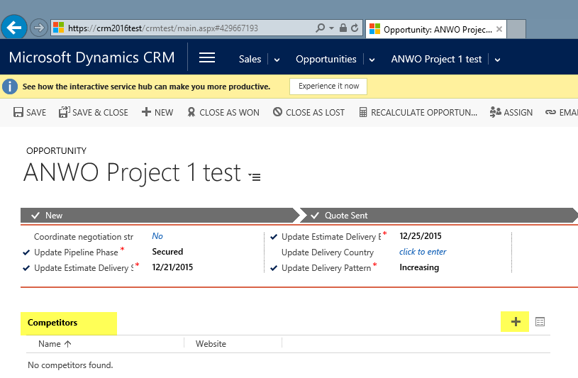

### 3.3.7 To add user for the Sales team that involved on the project

The Sales Team sub grid allows you to quickly add other internal users to the opportunity. This shows you who else is working on this opportunity besides the owner of the opportunity. Once you lookup and add a user to the Sales Team you are able to assign them a role: Account Manager, Delivery Professional, Industry Expert, Sales Professional, Service Professional, Technical Sales Professional and Territory Manager.

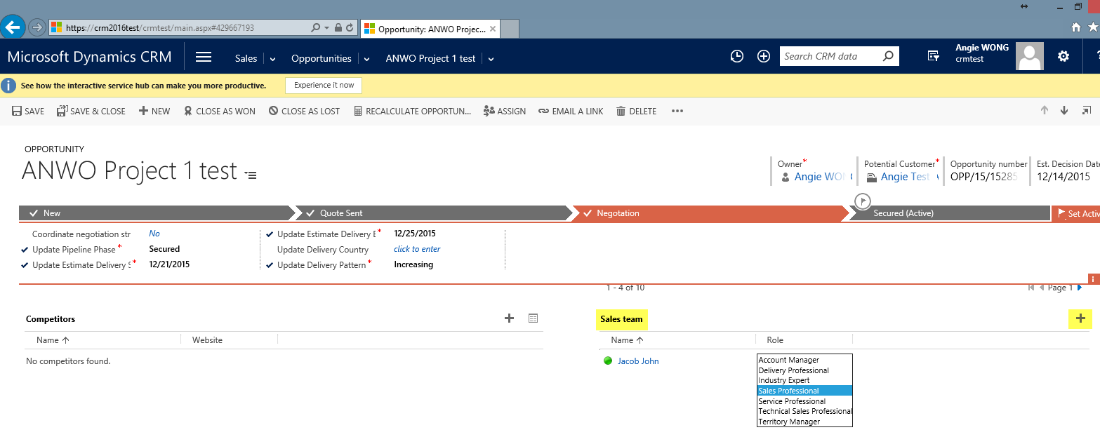

### 3.3.8 To add connection

User can access the Connection Associated View to connect opportunity to other entities via the Connection grid

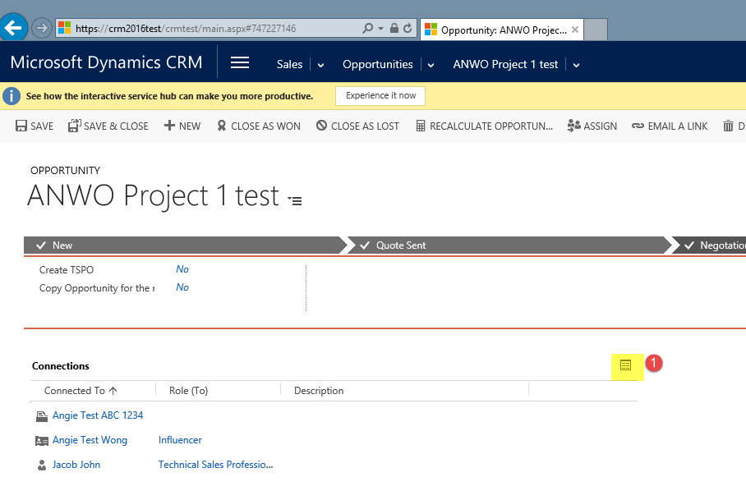

OR Connection module from the Associated grid

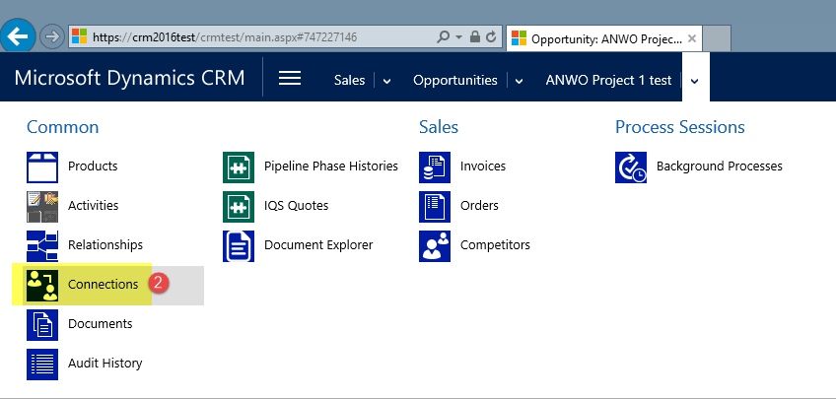

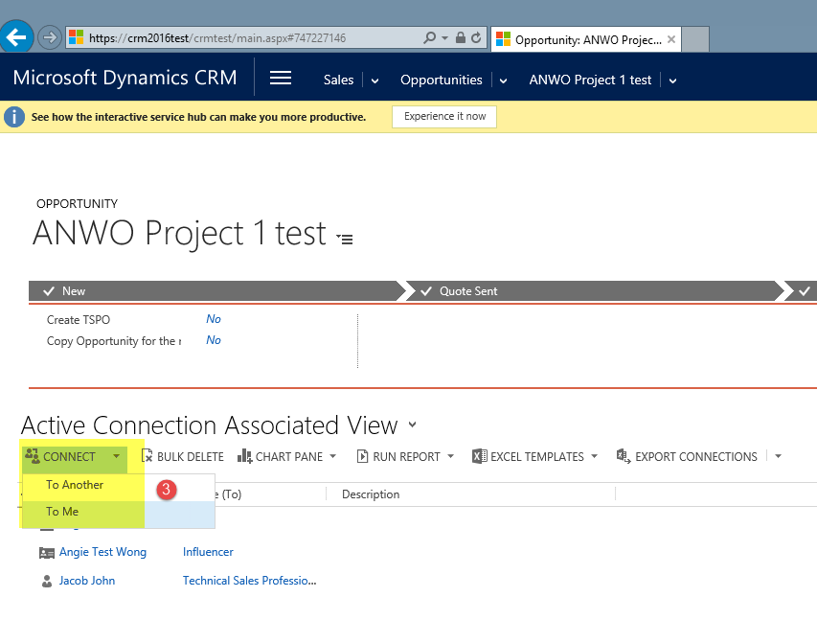

### 3.3.9 To access the document library folder for accessing IQS Quotation or Specification related to the Opportunity

The system will automatically create the document library folder upon new opportunity creation. User can access via the associated grid by click “Documents” entity

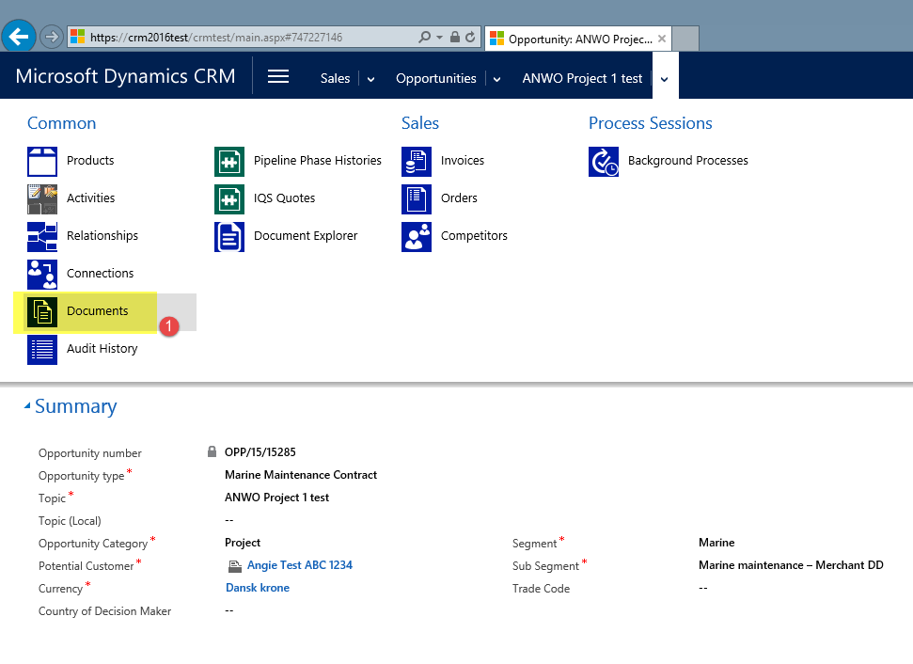

For those accounts that already synchronize with AX, the system will capture the archiving sales invoice, sales quotation and sales orders. User can just navigate to the folder to locate the needed documents. User can also click the “Add” button to add new document related to Account for example Agreements

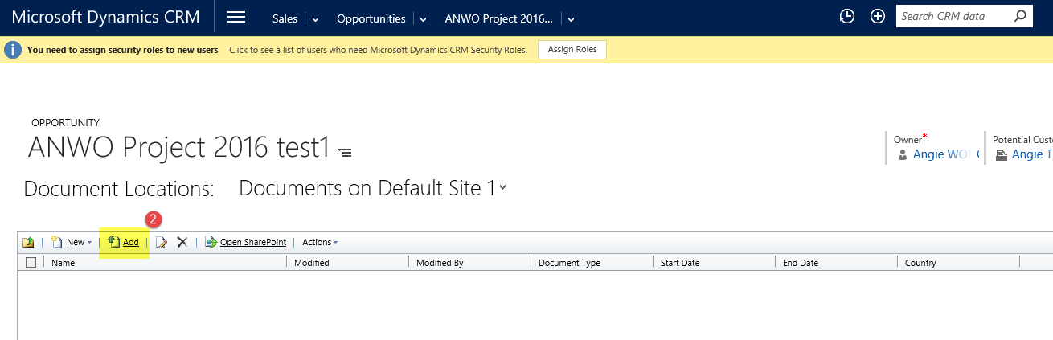

User has to browse for the file and click OK in order to upload the file to sharepoint

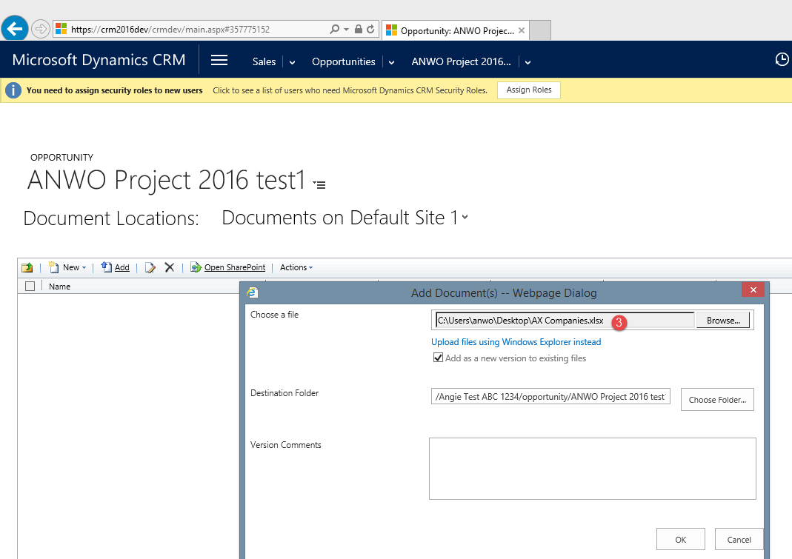

Before user can check-in the file, the user need to fill in some mandatory fields with relevant data.

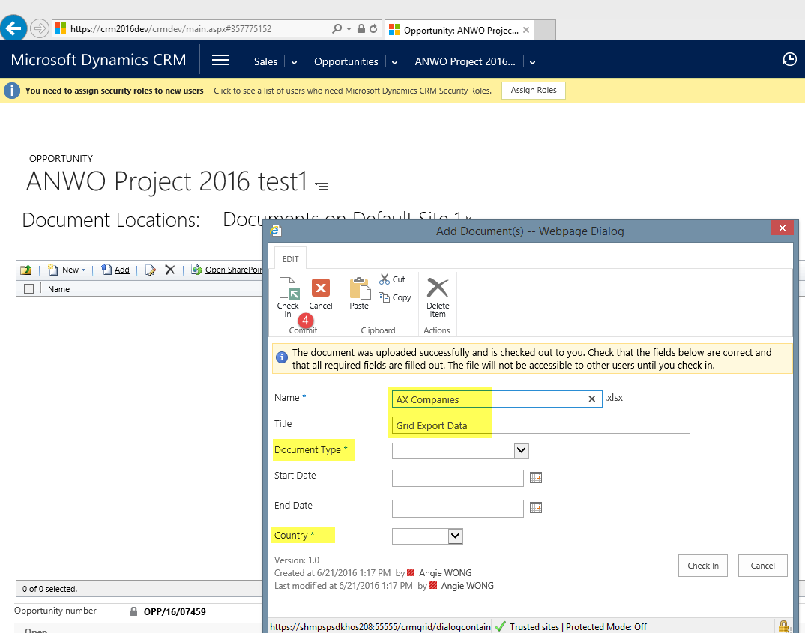

### 3.4.0 To assign or Share Opportunity to another user

User can used the Assign button or Share button to perform the necessary action.

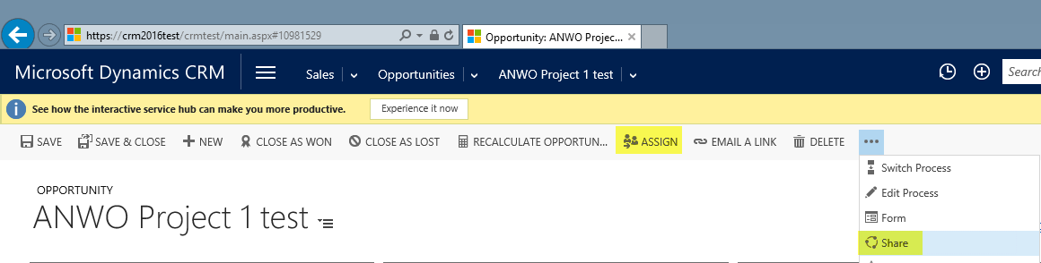

### 3.4.1 To COPY opportunity

In order to copy the same opportunity, user can click “Run Workflow” -> Select the workflow and click “Add”. The system will automatically create another opportunity with the same details but all the date is default to today’s date.

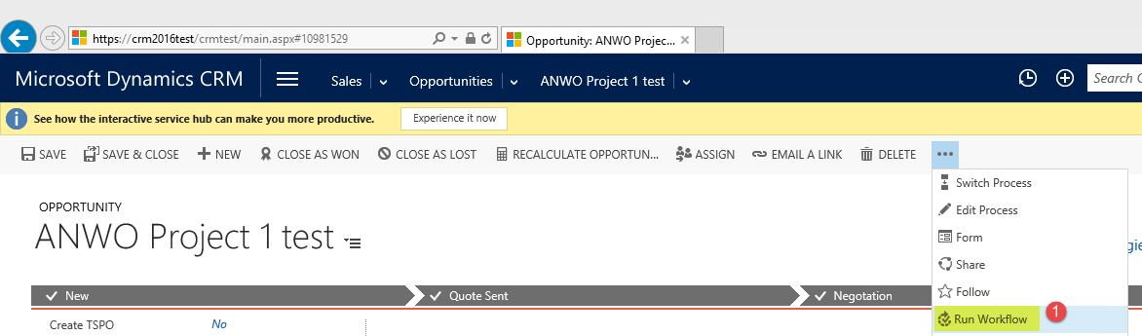

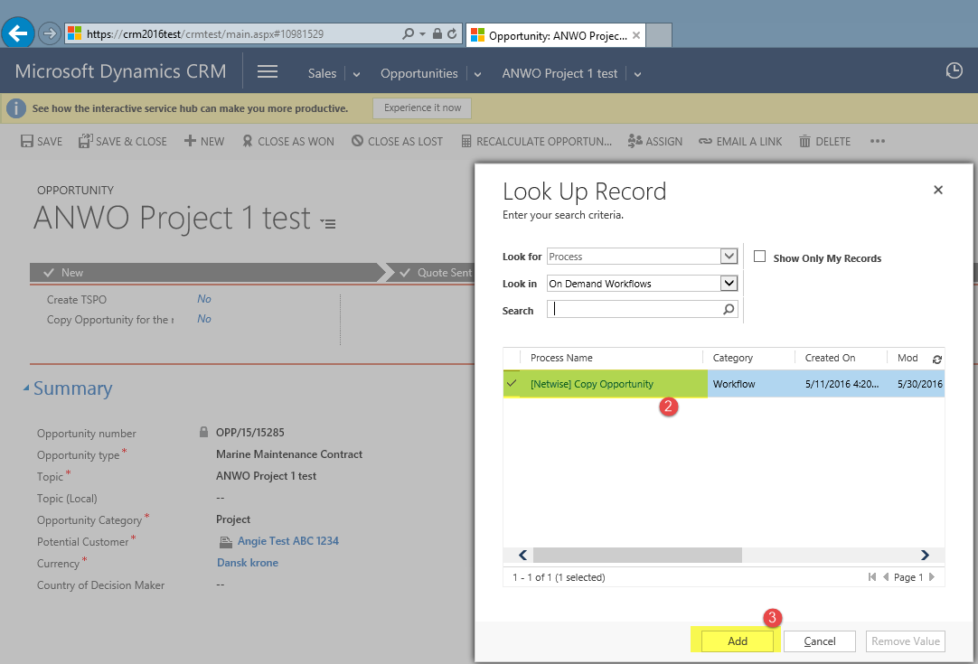

### 3.4.2 To Close the Opportunity as Won or as Lost

User can click on the “CLOSE AS WON” button to close the opportunity as Won

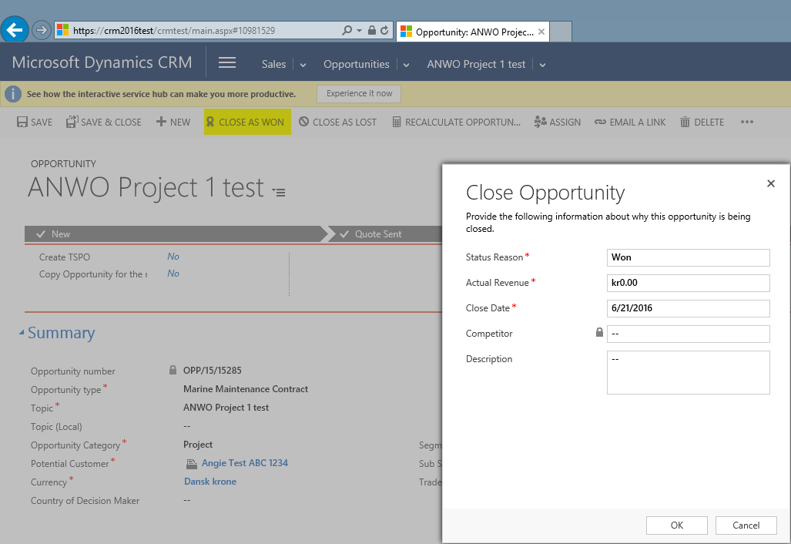

OR click on the “CLOSE AS LOST” button to close the opportunity as Lost with appropriate status reason. If lost to competitor, the user has to select the competitor. Any competitor that cannot be found from the lookup, user should select “Local Competitor” and key in the competitor name under Description field

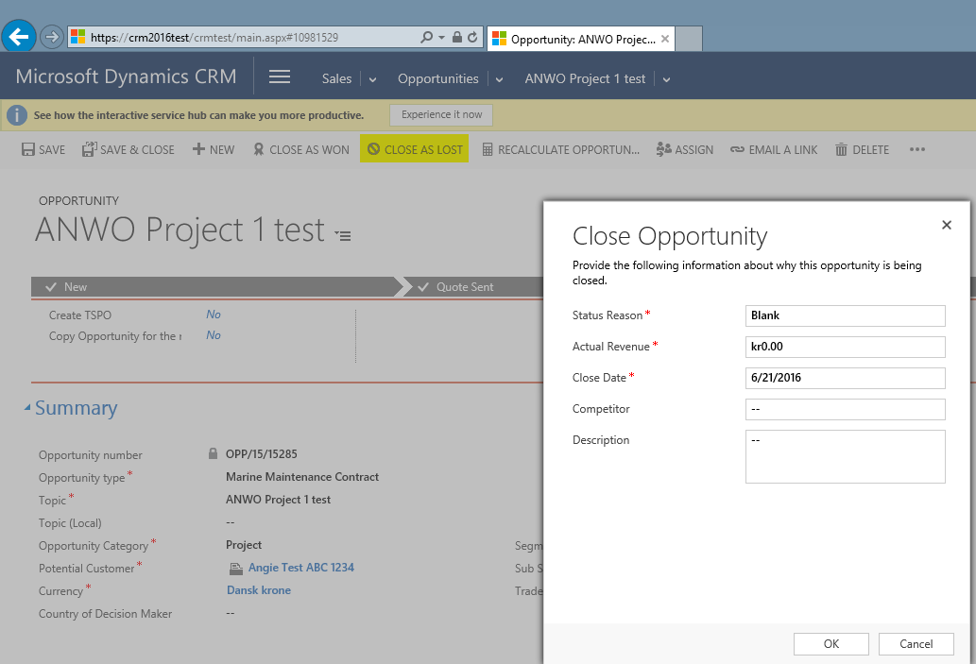

## 3.4 Contact

**A Contact is an individual that works for or is associated with an Account (customer).** A contact should always be linked to an Account. A contact must only be listed once even though it is active with more sales people, Accounts, Opportunities etc.

|  |  |
| --- | --- |
| General |  |
| Salutation | Mr. / Mrs. / Cpt. / Dr. etc |
| First Name | Given Name |
| Last Name* | Family Name, Mandatory |
| Job Title | Always fill in full title. No abbreviations. |
| Parent Customer | Select existing Account Company that employes this contact |
| Business Phone | No spaces between city codes and phone numbers |
| Home Phone | No spaces between city codes and phone numbers |
| Mobile Phone | No spaces between city codes and phone numbers |
| Fax | No spaces between city codes and phone numbers |

To create a new contact click on “New” in the “Contacts” section:

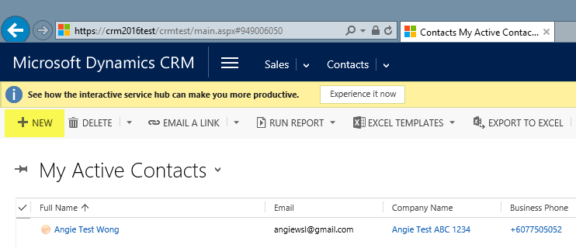

Or create using the quick create Contact form

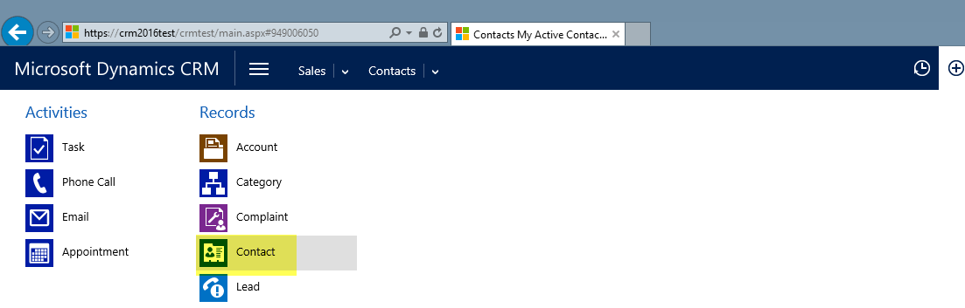

# How to create a view

1. Pick the view you want to use as starting point for your view (e.g. All Accounts or Open Opportunities).
2. Click on “Advanced Find”



1. The following window opens up. To start creating your view please save it as a separate view under a new name, it should be different from standard view names.

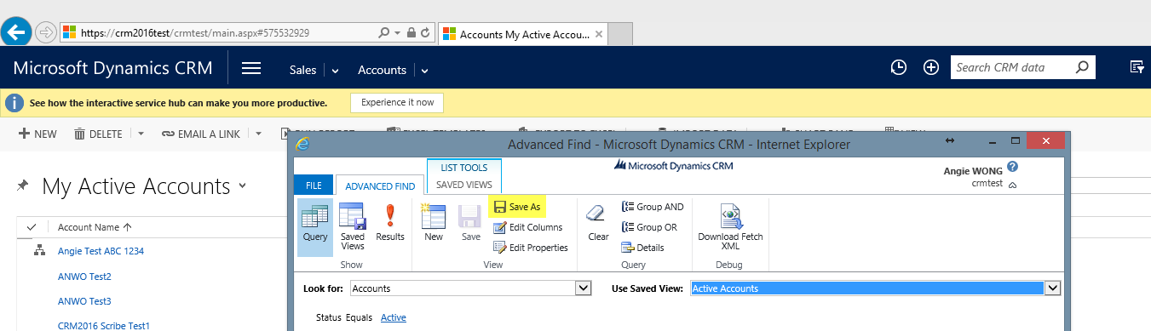

1. To prepare the filter(s) for the view please click on “Details”.
2. Then you need to change the view to what should be the data you want to filter. Like in this example Active Accounts. Then you click “select” to add your filter. Here you can pick any of the fields on the (in this case) Account.

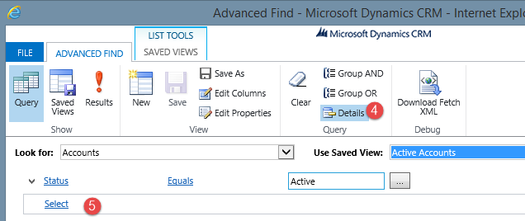

Filters below will give us all Active Downstream customers, which belongs to Jordi Borrell . This way you can combine different filters to see exactly what you need. Please note that if customer is from Downstream, but it has no data in the sub-segment field, it will not appear in this selection.

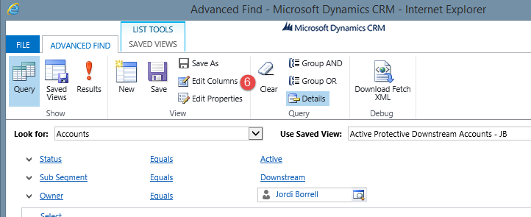

1. To add or delete columns click “Edit Columns” and the following below window opens. By adding columns you can create extensive Excel reports and it gives you access to all information on the different entities. If the field exists on the Account, Opportunity, etc. you can make reports on it and use it as filter.
2. Use the arrows to change the order of the columns if you wish to and click “add columns” if needed. Then you will have the following choice.
3. Here you will have the option of creating a column for each field that exist on the Account (the same will be the case if you try to do a view for opportunities, Contacts, etc.)
4. You can also create a column for a field on other entities related to an Account by clicking where it says “Account” and selecting “Originating Lead (Lead)” fx.
5. If you want to remove columns the following window opens. You need to mark the header of the columns you wish to remove and then click on “Remove” button.

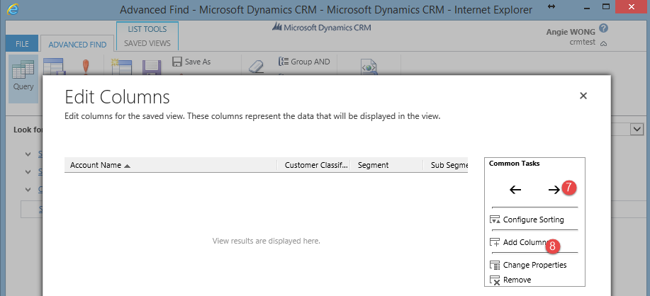

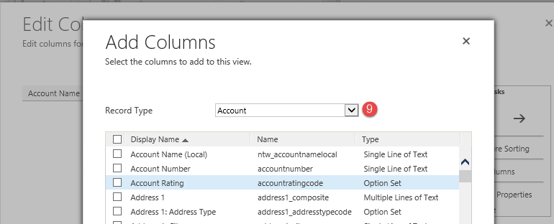

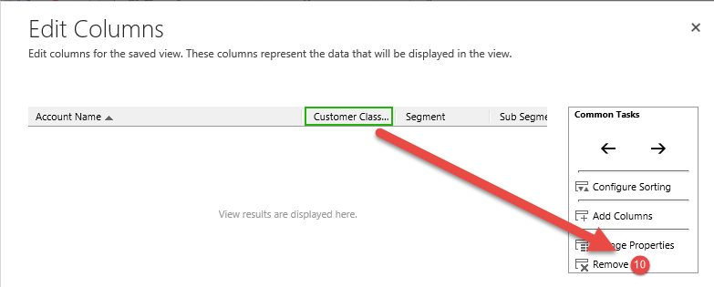

1. Click “Saved views” and in the new opened window you can click on “Deactivate” in order to deactivate it or delete the view by clicking on “Delete Saved View”.

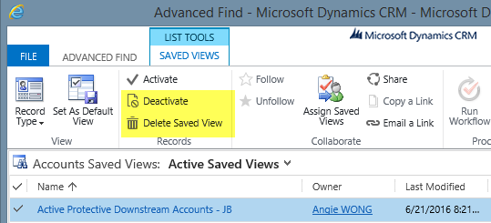

1. If you wish to share this view with a colleague then mark the view, click on “Share” and “Add User/Team”. In the new window you need to find a needed colleague and give him/her the permissions to the view that you want to share. It is possible to share a view with a team (fx team “Spain” means all CRM users from Spain).

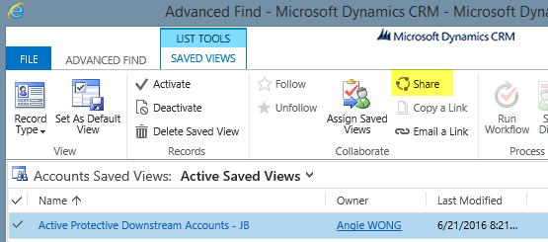

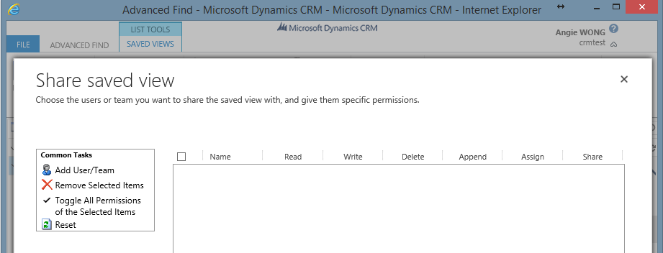

1. You can export the data from your view to Excel. To do that you need to click the Excel icon and then chose what kind of export you want.

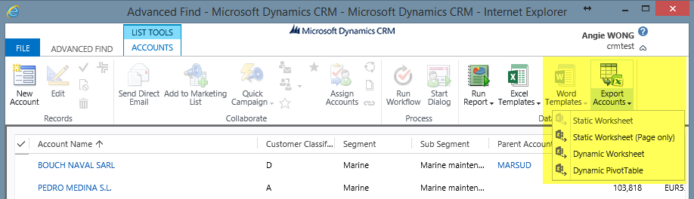

# Merging and Deactivate of duplicates

When working with account records in CRM, you might notice that the same record appears twice or even more times. This can happen fx because one contact (or account) was created several times by different sales reps.

In order to deactivate the record please mark it and click on “Deactivate” button on the “Account” or “Contact” menu bar.

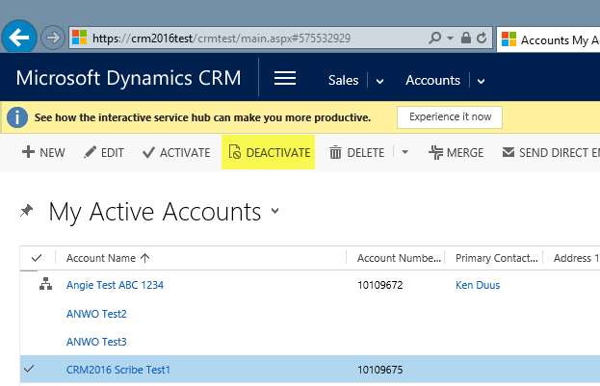

You can use the merge functionality to merge two records, so as a result you will have only one active record, and the second one will be deactivated automatically. To merge please select 2 records and click on “Merge”.

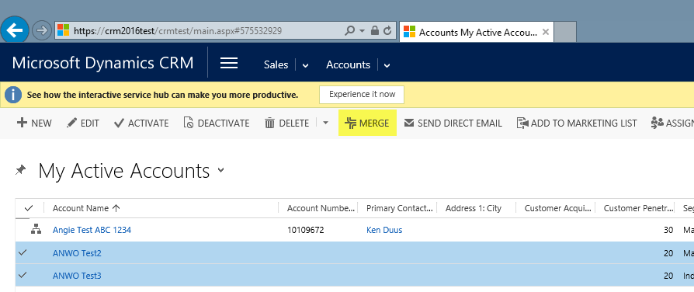

When you click on “Merge” button you will be prompted with following below window using which you can choose what information you will save on the Master record, which is going to be left after merging:

1. You need to define the master record which is at the end will remain active and other will get deactivated.
2. Select what information should be saved on the Master record (on the example below Primary contact, Phone and address information are selected from the second record).
3. Confirm merging and click on “Ok”.

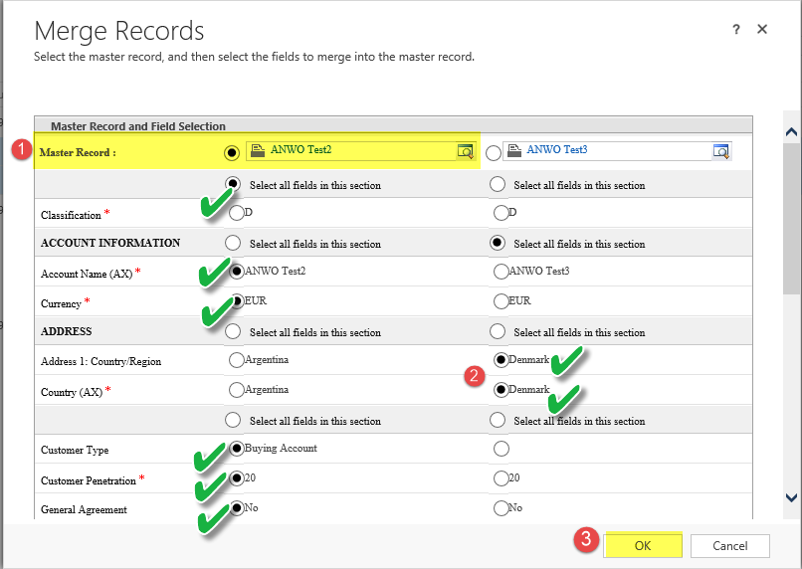

After you click ok, the system will deactivate the old account and transfer the details from subordinate record into master account, and the following below message will appear.

